

Ministry of Higher Education and Scientific Research​​
Scientific Supervision and Evaluation Authority​​​
Department of Quality Assurance and Academic Accreditation​​
Accreditation Department​​

Academic Program and Course Description Guide
Academic Program and Course Description Guide

2025
the introduction:
The educational program is a coordinated and organized package of courses that includes procedures and experiences organized into course vocabulary. Its main purpose is to build and refine the skills of graduates, making them qualified to meet the requirements of the labor market. It is reviewed and evaluated annually through internal or external audit procedures and programs, such as the external examiner program.
The academic program description provides a brief summary of the program’s main features and courses, indicating the skills that students are working to acquire based on the academic program’s objectives. The importance of this description is evident in that it represents the cornerstone for obtaining program accreditation, and it is written by the teaching staff under the supervision of the scientific committees in the academic departments.
This second edition of the guide includes a description of the academic program after updating the vocabulary and paragraphs of the previous guide in light of the developments and changes in the educational system in Iraq, which included a description of the academic program in its traditional form (annual, semester system), as well as adopting the generalized academic program description according to the Department of Studies' letter T M3/2906 dated 3/5/2023 with regard to programs that adopt the Bologna Process as the basis for their work.
In this regard, we cannot but emphasize the importance of writing descriptions of academic programs and courses to ensure the smooth running of the educational process.

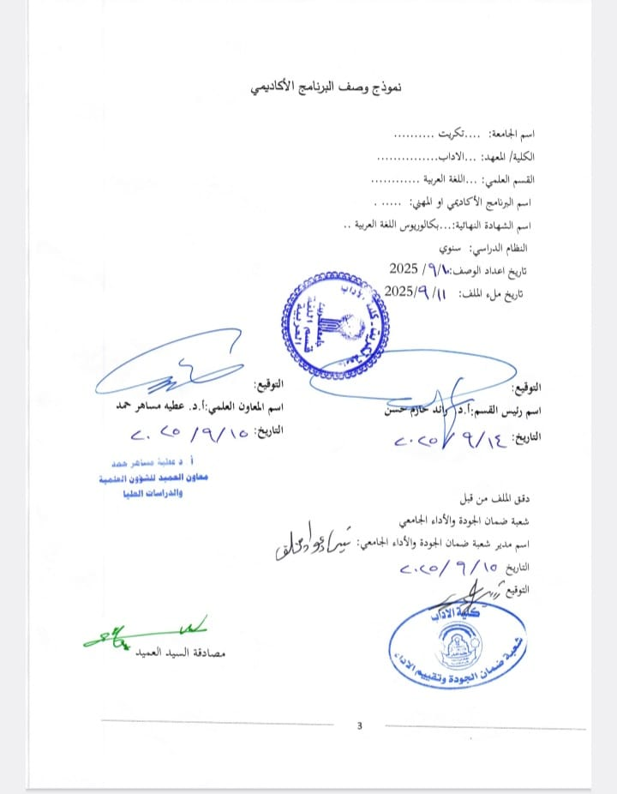

- Program Vision
The department strives for excellence, creativity, and innovation in providing distinguished scientific, educational, and pedagogical services in Arabic language and literature at both the undergraduate and graduate levels, in the fields of teaching and scientific research, in line with technological advancements and serving the local community. This vision for the department was developed to align with the directives of the Ministry of Higher Education and Scientific Research in achieving the Sustainable Development Goals and the United Nations 2030 Agenda.

- Program message
Preparing specialized educational and research personnel in Arabic language and literature to contribute to meeting the needs of the local market at the very least. This includes conducting various rigorous studies to serve the noble goals of the Arabic language and literature through diverse activities, lectures, workshops, and seminars (both online and in person), as well as strengthening cooperation and partnerships with relevant entities to build a bright future for the Arabic language.
- Program objectives
1. Preparing specialized and qualified scientific personnel (Bachelor’s and Master’s degrees) in the field of Arabic language, in its two branches, language and literature, enabling them to practice their work in the fields of education, media, journalism and translation.
2. To instill excellence and innovation in graduates by emphasizing modern knowledge and the correct foundations for building a sound Arabic language.
3. Instilling and developing high professional ethics embodied in the spirit and law of Islam among graduates when working in any of the various fields of work.
4. Working diligently to encourage students to produce scientific research characterized by rigor and preserving the integrity and spirit of the Arabic language.
5. Injecting new blood into the department by sending students abroad to learn about modern curricula in disciplines related to the Arabic language.
6. - Reconsidering the free courses within the Arabic language and literature specialization plan to create courses that contribute to expanding students’ knowledge in topics that serve their specialization, and to include courses for developing functional language skills and scientific research, for example.
- Program accreditation
Is the program accredited? If so, by which body? No
- Other external influences
Is there a sponsor for the program? No
- Program structure
Program structure | Number of courses | Study unit | Percentage | comments *
Institutional requirements | 37 | 156
College requirements | nothing
Department requirements | nothing
Summer training | nothing
Other | nothing
* The notes may include whether the course is core or elective.
7. Curriculum
First stage
T | Course Name | Credit Hours
T | Course Name | theoretical | practical | Number of units
 | Grammar | 3 |  | 6
 | Disbursement | 2 |  | 4
 | Pre-Islamic literature | 3 |  | 6
 | Rhetoric (the science of meanings ) | 2 |  | 4
 | Language skills | 2 |  | 4
 | Quranic sciences and methods of interpretation | 2 |  | 4
 | computer | 1 |  | 2
 | Human rights and democracy | 1 |  | 2
 | English language | 1 |  | 2
 | the total |  |  | 34
Phase Two
T | Course Name | Credit Hours
T | Course Name | theoretical | practical |  | Number of units
 | Grammar | 3 |  |  | 6
 | Islamic literature | 3 |  |  | 6
 | Disbursement | 2 |  |  | 4
 | Rhetoric (Expression and Figures of Speech) | 2 |  |  | 4
 | Offers | 2 |  |  | 4
 | The Old Book | 2 |  |  | 4
 | Library and research methodology | 2 |  |  | 4
 | computer | 1 |  |  | 2
 | English language | 1 |  |  | 2
 | Crimes of the Ba'ath regime in Iraq | 1 |  |  | 2
 | the total |  |  |  | 40
Phase Three
T | Course Name | Credit Hours
T | Course Name | theoretical | practical |  | Number of units
 | Grammar | 3 |  |  | 6
 | Abbasid literature | 3 |  |  | 6
 | Andalusian literature | 3 |  |  | 6
 | Linguistics | 2 |  |  | 4
 | The Old Book | 2 |  |  | 4
 | Ancient literary criticism | 2 |  |  | 4
 | Late Period Literature | 2 |  |  | 4
 | Analysis of the Qur'anic text | 2 |  |  | 4
 | the total |  |  |  | 38
Phase Four
T | Course Name | Credit Hours
T | Course Name | theoretical | practical |  | Number of units
1. | Grammar | 3 |  |  | 6
2. | Modern poetry | 2 |  |  | 4
3. | Comparative Literature | 2 |  |  | 4
4. | Linguistics | 2 |  |  | 4
5. | Modern prose | 2 |  |  | 4
6. | Literary schools | 2 |  |  | 4
7. | Grammar schools | 2 |  |  | 4
8. | Modern literary criticism | 3 |  |  | 6
9. | Research project | 2 |  |  | 4
10. | English language | 2 |  |  | 4
 | the total |  |  |  | 44

8. Expected learning outcomes of the program
Knowledge
1. To equip students with experience in thinking and analysis
2. To equip students with the ability to identify the problem of the phenomenon, its consequences, and how to address it.
Skills
Values
1. Enabling students to grasp the material both theoretically and practically
2. Enabling students to think and analyze in order to reach correct conclusions
3. Enabling students to prepare good scientific reports

9. Teaching and learning strategies
1. Using modern methods in teaching the subject
2. Using technological means to present scientific material, including data projectors and PowerPoint.

10 Assessment Methods
- Daily assessment through discussion + daily quizzes + monthly exams + practical assignments and faculty reports
11. Faculty
T | Instructor's Name | Certificate | Scientific title | position
 | Dr. Muhammad Khalil Ibrahim Dheeban | PhD | Mr
 | Dr. Hamad Mahmoud Mohamed Abdullah | PhD | Mr
 | Dr. Sajida Abdulkarim Khalaf Abdul | PhD | Mr
 | Dr. Sawsan Hadi Jaafar Ali | PhD | Mr
 | Dr. Sahar Ahmed Mohammed Jassim | PhD | Mr
 | Dr. Sahama Ghafoori Ali Ahmed | PhD | Mr
 | Dr. Saad Saleh Ahmed Dawood | PhD | Mr
 | D. Salah Sayer is hilarious | PhD | Mr
 | Dr. Muhannad Ahmed Hassan Hammadi | PhD | Mr
 | Dr. Nafi Hamad Muhammad Ahmad | PhD | Mr
 | Dr. Ibrahim Saleh Hussein Saleh | PhD | Mr
 | Dr. Muhammad Aziz Ali Akab | PhD | Mr
 | Dr. Basem Saleh Hussein | PhD | Mr
 | Dr. Abdullah Khalaf Saleh Helou | PhD | Mr
 | Dr. Sanaa Salman Abdul Jabbar Bakr | PhD | Mr
 | Dr. Izzat Ibrahim Hamash Khalaf | PhD | Mr
 | Dr. Muhammad Taha Fayyad Ibrahim | PhD | Mr
 | Dr. Sahera Hamada Salem | PhD | Mr
 | Dr. Nibras Khammas Muhammad Fayyad | PhD | Mr
 | Dr. Yasser Rashid Hamad Khamis | PhD | Mr
 | Dr. Ahmed Akab Dahour Ali | PhD | Mr
 | Dr. Fares Ali Saleh behind | PhD | Mr
 | Dr. Milad Adel Jamal Jalil | PhD | Mr
 | Dr. Raed Hazem Hassan Ibrahim | PhD | Mr
 | Dr. Adnan Khaled Fadl | PhD | assistant professor
 | Dr. Muhannad Majid excelled behind | PhD | Mr
 | Dr. Khadija I know Mohammed Shalash | PhD | assistant professor
 | Dr. Diaa Abdullah Mahmoud Alawi | PhD | assistant professor
 | Dr. Ahmed Atiya Alou Hammad | PhD | assistant professor
 | Dr. Affan Awf Abdulrahman Ahmed | Master's | assistant professor
 | Dr. Ghassan Alwan Khalaf Rajab | PhD | Mr
 | Dr. Abdulaziz Saleh Khalaf Salman | PhD | assistant professor
 | Dr. Youssef Abdulkarim Saleh Mohammed | PhD | assistant professor
 | Dr. Hashem Muhammad Tayawi | PhD | assistant professor
 | Dr. Iyad Saleh Alawi Khader | PhD | assistant professor
 | Dr. Rehab Mohamed Farag | PhD | assistant professor
 | Dr. Muhammad Abdel Qader Hatem Sultan | PhD | teacher
 | Dr. Abeer Aziz Aliwi Khalaf | PhD | teacher
 | Yasin Hamoud Mohammed Farhan | Master's | teacher
 | Dr. Dalia Hamid Shehab Ahmed | PhD | assistant professor
 | Dr. Diaa Hamed Hamoud Daher | PhD | teacher
 | Abdul-Moneim Saleh Ahmed Farhan | PhD | teacher
 | Mohammed Saleh Khalaf Hussein | PhD | teacher
 | Naseer Abdulhai Mohammed Abdulrahman | PhD | teacher
 | Munjid Ramadan Saleh | PhD | teacher
 | Mu'ayyad Salih Habib Allawi | PhD | teacher
 | Raghad Haitham Shams Khader | PhD | teacher
 | Ansam Nazim Jassim Mohammed | PhD | teacher
 | News of Haitham Muhammad | PhD | teacher
 | Muntaha Mushrif Alawi | PhD | teacher
 | Muthanna Jassim Aswad Salem | PhD | teacher
 | Khetam Abdel Salam Mustafa Hammadi | PhD | teacher
 | Saja Mu'ayyad Aboud | Master's | Assistant teacher
 | Maher Aswad Zidan Dayeh | Master's | Assistant teacher
 | Iskandar Habib Salem Hussein | Master's | Assistant teacher
 | Shahbaa Abdul Razzaq Karim Omar | Master's | Assistant teacher
 | Nazeer Jassim Mohammed Farhan | Master's | Assistant teacher
 | Khamis Abdullah Khalil Abdul | Master's | Assistant teacher
 | David's agate cupping | Master's | Assistant teacher
 | Virgin of Qader Shaker | Master's | Assistant teacher
 | Mohammed generous Nawaf Dweish | Master's | Assistant teacher
 | safe useful Ismael Abdullah | Master's | Assistant teacher
 | Yasmine slave dear Salem Farhan | Master's | Assistant teacher
 | Fatima Laith slave Al-Razzaq Taha | Master's | Assistant teacher
 | Hafsa Ibrahim Saleh | Master's | Assistant teacher
 | Hassan Fallah Abdul Karim | Master's | Assistant teacher
 | Rehab Abdel Salam Mustafa | Master's | Assistant teacher
 | Aya Hussein Khalaf Faisal | Master's | Assistant teacher
 | Randa Abdel Hamid Abdullah | Master's | Assistant teacher
 | Ahmed Sadek Mohamed Ali | Master's | Assistant teacher
 | Mohammed Saleh Ibrahim | Master's | Assistant teacher
12. Professional Development
Orienting new faculty members
1. Involving them in some committees
2. Involving them in courses
3. Encouraging them to conduct scientific research
Professional development of faculty members
1. Involving them in scientific and administrative committees
2. Involving them in courses
3. Encouraging them to conduct scientific research

13. Admission Criteria
1. Centralized admission by the Ministry of Higher Education
2. Admission based on the preparatory school certificate in its two branches (literary and scientific)
14. Key sources of information about the program
1. Recent scientific sources in Arabic and English
2. Arabic and English scientific journals
3. The professors' experience over the years

15. Program Development Plan
1. Developing a program to improve teaching staff by supporting and increasing development courses, and aligning it with international universities.
2. Developing a curriculum development program by creating new and advanced curricula, relying on technological development, especially (artificial intelligence).
3. Preparing the final stage of student projects, which includes laboratory work, field visits, information gathering, preparing statistics, and presenting the results in the form of reports prepared for the department, which aim to prepare the student for integration into the labor market.
4. Developing a program to improve publishing and scientific research by participating in courses on publishing in Clarivate and Scopus databases and relying on modern scientific ideas.
5. The possibility of cooperating with several institutions, including the General Authority for Meteorology and the Ministry of Planning's Statistics Department. Information Systems Department.

Course Description Template / Modern Literature
- Course Name : Tikrit University / College of Arts
- Course code: Modern Literature
/
- Semester/Year: 2025-2026
annual
- Date this description was prepared:
11/9/2025​​​​
- Available attendance formats :
My presence
- Number of study hours (total) / Number of units (total):
30 hours / Number of units:
- Name of the course coordinator (if there is more than one, please state):
Name: Prof. Dr. Sajida Abdulkarim Khalaf
- Course objectives
Familiarization with modern critical terminology
Understanding modern literary and critical issues
Highlighting the concepts and mechanisms of modern criticism and its reflection in literature

- Teaching and learning strategies
debates and interviews oral and liberation
- Course structure
Week | Hours | Required learning outcomes | Unit or topic name |  | Learning method | Evaluation Method
the first
the second
the third
Fourth
Fifth
Sixth
The suffix
Eighth
Ninth
tenth
eleventh
twelfth
Thirteenth
Fourteenth
fifteenth
- Course evaluation
- Reports.
- Lectures given by students and their daily attendance.
- Research.
- Written exams
- Oral questions
- Learning and teaching resources
Required textbooks (methodology, if applicable) |  |  |  | Nothing
Main references (sources)
Recommended supporting books and references (scientific journals, reports...)
Electronic references, websites |  |  |  | There is no specific location, and most of the electronic references are those mentioned above.

Course description template
- Course name and code:
Late Period Literature
- Chapter/Year:
annual
- Date this description was prepared
11/9/2025
- Available attendance formats :
My presence
- Number of study hours (total) / Number of units (total):
90
- Name of the course coordinator (if there is more than one, please mention it).
M.D. Naseer Abdul-Hay Muhammad

- Course objectives
The course aims to teach students about the most important political, social, and cultural events after the fall of
First, the student learns that the period following the fall of Baghdad in 656 AH to the Mongols is called the "Dark Period," a term we believe to be incorrect.
Literature, though influenced by political and social conditions, did not descend to the lowest depths of decline and decadence, as we find within it bright pages that add to the pages it witnessed throughout the ages.
Which preceded the fall of Baghdad and the collapse of the Abbasid Caliphate.

- Teaching and learning strategies
- The lecture.
- Discussion.

- Course structure
Week | Hours | Required learning outcomes | Unit/Course or Topic Name | Teaching method | Evaluation Method
1 | Two hours | to understand the topic | Political, social and cultural life | Lecture and discussion | Written and oral questions
2 | Two hours | to understand the topic | Poetry and its artistic characteristics | Lecture and discussion | Written and oral questions
3 | Two hours | Understanding and Analysis | Newly developed poetic arts | Lecture and discussion | Written and oral questions
4 | Two hours | Understanding and Analysis | The dubit | Lecture and discussion | Written and oral questions
5 | Two hours | Understanding and Analysis | Muwashshah | Lecture and discussion | Written and oral questions
6 | Two hours | Understanding and Analysis | zajal | Lecture and discussion | Written and oral questions
7 | Two hours | Understanding and Analysis | Loyalists | Lecture and discussion | Written and oral questions
8 | Two hours | Understanding and Analysis | It was and it was | Lecture and discussion | Written and oral questions
9 | Two hours | Understanding and Analysis | The people | Lecture and discussion | Written and oral questions
10 | Two hours | Understanding and Analysis | Item | Lecture and discussion | Written and oral questions
11 | Two hours | Understanding and Analysis | Poets (Shams al-Din al-Kufi) | Lecture and discussion | Written and oral questions
12 | Two hours | Understanding and Analysis | Sharaf al-Din Muhammad ibn Sa'id al-Busri | Lecture and discussion | Written and oral questions
13 | Two hours | Understanding and Analysis | Safi al-Din al-Hilli | Lecture and discussion | Written and oral questions
14 | Two hours | Understanding and Analysis | Ibn Zaylaq al-Mawsili | Lecture and discussion | Written and oral questions
15 | Two hours | Understanding and Analysis | Shihab al-Din al-Talafari | Lecture and discussion | Written and oral questions
16 | Two hours | Understanding and Analysis | Taqi al-Din ibn Hujjah al-Hamawi | Lecture and discussion | Written and oral questions
17 | Two hours | Understanding and Analysis | Fudhuli al-Baghdadi | Lecture and discussion | Written and oral questions
18 | Two hours | Understanding and Analysis | Ibn Ma'tuq al-Musawi | Lecture and discussion | Written and oral questions
19 | Two hours | Understanding and Analysis | Prose and its types | Lecture and discussion | Written and oral questions
20 | Two hours | Understanding and Analysis | oratory | Lecture and discussion | Written and oral questions
21 | Two hours | Understanding and Analysis | Diwani writing | Lecture and discussion | Written and oral questions
22 | Two hours | Understanding and Analysis | Brotherhood messages | Lecture and discussion | Written and oral questions
23 | Two hours | Understanding and Analysis | Other arts | Lecture and discussion | Written and oral questions
24 | Two hours | Understanding and Analysis | The book | Lecture and discussion | Written and oral questions
25 | Two hours | Understanding and Analysis | Abu Abbas al-Qalqashandi | Lecture and discussion | Written and oral questions
26 | Two hours | Understanding and Analysis | Youssef Al-Badi'i | Lecture and discussion | Written and oral questions
27 | Two hours | Understanding and Analysis | Abdul Qadir ibn Umar al-Baghdadi | Lecture and discussion | Written and oral questions

Course evaluation
Open dialogue, Applications The process, presentation Questions To arouse Thinking, And others .

- Learning and teaching resources
Required textbooks (methodology, if applicable) | In the literature of later periods /  Dr. Nazim Rashid
Main references (sources)
Recommended supporting books and references (scientific journals, reports...)
Electronic references, websites

Course description template
- Course Name : English Poetry
Ibn Aqil's commentary on Ibn Malik's Alfiyya
- Course code :
- Semester / Year : Annual
2025/2026
- Date this description was prepared
11/9/2025
- Available attendance formats :
Attendance in the classroom
- Number of study hours (total) / Number of units (total):
3 hours per week
- Name of the course coordinator (if there is more than one, please mention it).
Dr. Hashim Mohammed Tayawi
- Course objectives
Enabling the student to master grammatical structure and correct pronunciation.
Rhetoric and Grammar
- Teaching and learning strategies
- Course structure
Week | Hours | Required learning outcomes | Unit or topic name |  |  |  | Learning method | Evaluation Method
the first | 3 | Understanding the assigned subject  And the ability to answer  Regarding the questions raised  Which pertains to the topic | Grammar for the fourth stage  (Ibn Aqil's explanation) |  |  |  | Giving a lecture  and use  blackboard | Oral questions
- Course evaluation
A curriculum that is sufficient for the student and teaches him to master words and pronounce them correctly.
- Learning and teaching resources
Required textbooks (methodology, if applicable) |  |  |  |  |  | Ibn Aqil's commentary on Ibn Malik's Alfiyya
Main references (sources) |  |  |  |  |  | Sibawayh's book; The Clearest Paths  On Ibn Malik's Alfiyya by Ibn Hisham
Recommended supporting books and references (scientific journals, reports...) |  |  |  |  |  | Explanation of Ibn Malik's Alfiyya by Al-Shinqiti
Electronic references, websites |  |  |  |  |  | Google; the site of the people of remembrance

Course description template
- Course Name : Grammar and The app
Ibn Aqil's commentary on Ibn Malik's Alfiyya
- Course code :
- Semester / Year : Annual
2025/2026​​
- Date this description was prepared
11/9/2025
- Available attendance formats :
Attendance in the classroom
- Number of study hours (total) / Number of units (total):
3 hours per week
- Name of the course coordinator (if there is more than one, please mention it).
M.D. Diaa​​​ Hamed praiseworthy
- Course objectives
Enabling the student to master grammatical structure and correct pronunciation.
Rhetoric and Grammar
- Teaching and learning strategies
- Course structure
Week | Hours | Required learning outcomes | Unit or topic name |  |  |  | Learning method | Evaluation Method
the first | 3 | Understanding the assigned subject  And the ability to answer  Regarding the questions raised  Which pertains to the topic | Grammar for the first stage  (Ibn Aqil's explanation) |  |  |  | Giving a lecture  and use  blackboard | Oral questions
- Course evaluation
A curriculum that is sufficient for the student and teaches him to master words and pronounce them correctly.

- Learning and teaching resources
Required textbooks (methodology, if applicable) |  |  |  |  |  | Ibn Aqil's commentary on Ibn Malik's Alfiyya
Main references (sources) |  |  |  |  |  | Sibawayh's book; The Clearest Paths  On Ibn Malik's Alfiyya by Ibn Hisham
Recommended supporting books and references (scientific journals, reports...) |  |  |  |  |  | Explanation of Ibn Malik's Alfiyya by Al-Shinqiti
Electronic references, websites |  |  |  |  |  | Google; the site of the people of remembrance
Course description template
- Course Title : Modern Literary Criticism
- Course code : 02
- Semester / Year : Annual
Annual system
- Date this description was prepared
11/9/2025
- Available attendance formats :
1. In person 2. Online
In-person classes + an online class on Google Classroom will serve as a supplementary class to the in-person class.
According to the regulations and instructions of the Ministry of Higher Education and Scientific Research
- Number of study hours (total) / Number of units (total):
54 hours per academic year
- Name of the course coordinator (if there is more than one, please mention it).
1. Prof. Dr. Nafi Hammad Muhammad
2. M.M.​​ Hassan peasant slave The generous
- Course objectives
Teaching and introducing students to everything related to modern criticism, including knowledge of art terms, doctrines, and schools.
- Course structure
Week | Hours | Required learning outcomes | Unit or topic name | Learning method |  | Evaluation Method
Week 1  November 11, 2025 | Two hours | They did not begin |  |  |  | They did not begin
Week 2  November 17, 2025 | Two hours |  | Poetry and Currents of Criticism | The standard method: reading, analysis, and application. |  | Classroom performance and exams
November 11, 2025 | Two hours |  | Elements of the poem | The standard method: reading, analysis, and application. |  | Classroom performance and exams
Week 3  November 24, 2025 | Two hours |  | Plato's view on poetry | The standard method: reading, analysis, and application. |  | Classroom performance and exams
Week 4  1/December 2025 | Two hours |  | Aristotle's critique of poetry | The standard method: reading, analysis, and application. |  | Classroom performance and exams
Week 5  December 8, 2025 | Two hours |  | Elements of literary impact | The standard method: reading, analysis, and application. |  | Classroom performance and exams
Week 6  January 15  202 5 | Two hours |  | Emotion and its place in the text | The standard method: reading, analysis, and application. |  | Classroom performance and exams
Week 7  December 23, 2025 | Two hours |  | The idea in the literary text | The standard method: reading, analysis, and application. |  | Classroom performance and exams
Week 8  December 29, 2025 | Two hours |  | First monthly exam | The standard method: reading, analysis, and application. |  | Classroom performance and exams
 | Two hours |  | Imagination and its role in literature and poetry | The standard method: reading, analysis, and application. |  | Classroom performance and exams
 | Two hours |  | The image in literature | Method 1, Week 9  January 5, 2026  Week 10  January 12  25 02  Standardized reading, analysis, and application methods |  | Classroom performance and exams
Week Eleven  January 19 | Two hours |  | The meaning of the image | The standard method: reading, analysis, and application. |  | Classroom performance and exams
Week Twelve  January 26, 2025 | Two hours |  | Image elements | The standard method: reading, analysis, and application. |  | Classroom performance and exams
Week 13  February 2, 2025 | Two hours |  | Arabic poetry and Al-Khalil's meters | The standard method: reading, analysis, and application. |  | Classroom performance and exams
Week Fourteen  February 9, 2025 | Two hours |  | Arabic poetry column | The standard method: reading, analysis, and application. |  | Classroom performance and exams
Week fifteen  February 16, 2025 | Two hours |  | Second month exam | The standard method: reading, analysis, and application. |  | Classroom performance and exams
Week 16  March 9, 2025 | Two hours |  | After the spring break: Modern Arabic criticism and its development | The standard method: reading, analysis, and application. |  | Classroom performance and exams
Week 17  March 16, 2025 | Two hours |  | Ancient Arabic criticism and its influence on our modern criticism | The standard method: reading, analysis, and application. |  | Classroom performance and exams
Week 18  March 23, 2025 | Two hours |  | The Theory of Systems according to Al-Qahir Al-Jurjani | The standard method: reading, analysis, and application. |  | Classroom performance and exams
Week 9  March 30, 2025 | Two hours | Eid al-Fitr holiday
Week 20  April 6, 2025 | Two hours |  | Western critical trends and their impact on modern Arabic criticism | The standard method: reading, analysis, and application. |  | Classroom performance and exams
Week 21  April 13, 2025 | Two hours |  | Modern Criticism Schools | The standard method: reading, analysis, and application. |  | Classroom performance and exams
Week 22  April 20, 2025 | Two hours |  | Modern Foundations in Poetry Criticism | The standard method: reading, analysis, and application. |  | Classroom performance and exams
Week 23  April 27, 2025 | Two hours |  | Freud's school and the world of the unconscious | The standard method: reading, analysis, and application. |  | Classroom performance and exams
Week 24  May 4, 2025 | Two hours |  | First month exam | The standard method: reading, analysis, and application. |  | Classroom performance and exams
Week 25  May 11, 2025 | Two hours |  | poetic experience | The standard method: reading, analysis, and application. |  | Classroom performance and exams
Week 26  May 18, 2025 | Two hours |  | The organic unity of the poem | The standard method: reading, analysis, and application. |  | Classroom performance and exams
Week 27  May 25, 2025 | Two hours |  | Major Schools of Modern Criticism | The standard method: reading, analysis, and application. |  | Classroom performance and exams
Week 28  June 1, 2025 | Two hours |  | Classical school | The standard method: reading, analysis, and application. |  | Classroom performance and exams
Week 29  June 8, 2025 | Eid al-Adha holiday according to the Gregorian calendar
Week 30  June 23, 2025 |  |  | Second exam
- Course evaluation
- Learning and teaching resources
Required textbooks (methodology, if applicable) |  |  | Modern literary criticism
Main references (sources) |  |  | Literary criticism by Ahmed Amin
Recommended supporting books and references (scientific journals, reports...) |  |  | Criticism and Contemporary Critics: Muhammad Mandour
Electronic references, websites |  |  | Comprehensive Library

Course description template
- Course Name : Rhetorical Studies
- Course code :
- Chapter 1​
- This description was prepared on 11/9/2025
- Available forms of attendance : In-person attendance
- Total study hours/total units: 45
- Name of the course coordinator (if there is more than one, please state): Prof. Dr. Muhammad Khalil Ibrahim
- Course objectives
Understanding Abdul Qahir Al-Jurjani's approach to presenting the theory of systems. |  |  |  |  |  | Informing students about the most important book in rhetoric, which is the book “Dala’il al-I’jaz” by Al-Jurjani.
- Teaching and learning strategies
- Course structure
Week | Hours | Required learning outcomes | Unit or topic name |  |  |  | Learning method | Evaluation Method
1-2 |  | to understand the topic | The discussion of precedence and postponement |  |  |  | Lecture and discussion | Written and oral questions
3-5 |  | to understand the topic | The difference between fronting the verb and fronting the subject in a question |  |  |  | Lecture and discussion | Written and oral questions
6-9 |  | Understanding and Analysis | Presentation in negative news and presentation in affirmative news |  |  |  | Lecture and discussion | Written and oral questions
10-11 |  | Understanding the topic | Presenting (like) and (other than) |  |  |  | Lecture and discussion | Written and oral questions
12-13​ |  | Understanding the topic | Presenting the indefinite noun in the predicate |  |  |  | Lecture and discussion | Written and oral questions
13-14 |  | Understanding the topic | The discussion of deletion |  |  |  | Lecture and discussion | Written and oral questions
14-15 |  | Understanding the topic | Chapter on Separation and Connection |  |  |  | Lecture and discussion | Written and oral questions
- Course evaluation
Questions Direct, Exams Daily, Participation And the attendance Actual, Discussions with Students, Duties Daily and applications , The two semester exams.

- Learning and teaching resources
Required textbooks (methodology, if applicable) |  |  |  |  | Book of Signs of Inimitability
Main references (sources) |  |  |  |  | The foundational texts of rhetoric
Recommended supporting books and references (scientific journals, reports...) |  |  |  |  | Research concerned with rhetorical studies and the meanings of grammar
Electronic references, websites

Course description template
- Course Name : English Language
- Course code :
- Chapters 1 and 2
- Date this description was prepared : 1/9/2025
- Available forms of attendance : In-person attendance
- Total study hours/total units: 45
- Name of course coordinator (if more than one name is used, please specify): Ms. Randa Abdul Hamid Abdullah
- Course objectives
- Learn English grammar rules, tenses, and adverbs |  |  |  |  |  | Enabling students to create grammatical sentences for different tenses
- Teaching and learning strategies
- Course structure
Week | Hours | Required learning outcomes | Unit or topic name |  |  |  | Learning method | Evaluation Method
1-2 |  | Getting to speak with people | Getting to know you |  |  |  | Lecture and discussion | and oral questions
3-5 |  | Grammar spot | Getting to know you |  |  |  | Lecture and discussion | Written and oral questions
6-9 |  | People and places | The way we live |  |  |  | Lecture and discussion | Written and oral questions
10-11 |  | Practice | The way we live |  |  |  | Lecture and discussion | Written and oral questions
12-13​ |  | The burglars | It all went wrong |  |  |  | Lecture and discussion | Written and oral questions
13-14 |  | Everyday English | It all went wrong |  |  |  | Lecture and discussion | Written and oral questions
14-15 |  | Grammar spot | Let's go shopping |  |  |  | Lecture and discussion | Written and oral questions
- Course evaluation
Questions Direct, Exams Daily, Participation And the attendance Actual, Discussions with Students, Duties Daily and applications , The two semester exams.

- Learning and teaching resources
Required textbooks (methodology, if applicable)
Main references (sources)
Recommended supporting books and references (scientific journals, reports...) |  |  |  |  | Research related to the English language
Electronic references, websites

Course description template
- Course Name : English Language
- Course code :
- Chapters 1 and 2
- This description was prepared on 11/9/2025
- Available attendance formats: In-person attendance
- Total study hours/total units: 45
- Name of course coordinator (if more than one name is used, please specify): Ms. Randa Abdul Hamid Abdullah
- Course objectives
- To learn English grammar rules, tenses, and adverbs |  |  |  |  |  | Enabling students to create grammatical sentences for different tenses
- Teaching and learning strategies
- Course structure
Week | Hours | Required learning outcomes | Unit or topic name |  |  |  | Learning method | Evaluation Method
1-2 |  | Getting to speak with people | Getting to know you |  |  |  | Lecture and discussion | and oral questions
3-5 |  | Grammar spot | Getting to know you |  |  |  | Lecture and discussion | Written and oral questions
6-9 |  | People and places | The way we live |  |  |  | Lecture and discussion | Written and oral questions
10-11 |  | Practice | The way we live |  |  |  | Lecture and discussion | Written and oral questions
12-13 |  | The burglars | It all went wrong |  |  |  | Lecture and discussion | Written and oral questions
13-14 |  | Everyday English | It all went wrong |  |  |  | Lecture and discussion | Written and oral questions
14-15 |  | Grammar spot | Let's go shopping |  |  |  | Lecture and discussion | Written and oral questions
- Course evaluation

Direct questions, daily exams, participation and actual attendance, discussions with students, daily assignments and applications, and the two semester exams.

- Learning and teaching resources

Required textbooks (methodology, if applicable)

Main references (sources)
Recommended supporting books and references (scientific journals, reports...) |  |  |  |  | Research related to the English language

Electronic references, websites

Course description template
- Course Name : English Poetry

Modern poetry
- Course code :
- Semester / Year : Annual

annual
- Date this description was prepared

11/9/2025
- Available attendance formats:

My presence
- Number of study hours (total) / Number of units (total):

90
- Name of the course coordinator (if there is more than one, please mention it).

Dr. Muhammad Saleh Khalaf

- Course objectives

The aim of the course is to learn about modern Arabic literature, both poetry and prose, and to learn about the most important pioneers and contemporary poetic schools, and then to form a special idea about the most important artistic phenomena.
- Teaching and learning strategies

In-depth group discussions, instruction to train students in the subject's fundamental skills, generating numerous ideas to cultivate active thinking and deeper exploration of topics within their applied fields, providing students with primary and secondary topics related to modern literature, and requiring students to follow poetic schools through exposure to the curriculum's vocabulary.

- Course structure
Week | Hours | Required learning outcomes | Unit or topic name |  |  |  | Learning method | Evaluation Method
2_1  5_3  9_6  9_6 |  | Understanding the topic  Understanding the topic  Understanding the topic | Literary life and the factors contributing to its revival  Modern Arabic poetry  Iraqi poetry in the nineteenth century |  |  |  | Lecture and discussion  discussion | Oral and written questions  Questions for healing
- Course evaluation
- Learning and teaching resources
Required textbooks (methodology, if applicable) |  |  |  |  | Modern Arabic Literature: A Study of its Poetry and Prose, by Salem Al-Hamdani and Faiq Mustafa.
Main references (sources) |  |  |  |  | Modern Arabic Literature: Its Origins and Development, by Hassan Muhammad
Recommended supporting books and references (scientific journals, reports...) |  |  |  |  | Journal of Arabic Language Sciences
Electronic references, websites |  |  |  |  | Websites that focus on the study of modern poetry

Course description template
- Course Name : Classical Literary Studies
- Course code :
- Semester / Year : My semester
- Date this description was prepared

11/9/2025
- Available attendance formats: In-person
- Total study hours/total units: 3
- Name of the course coordinator (if there is more than one, please state): Prof. Dr. Nibras Khammas Muhammad

Course Objectives: 1. To provide the student with in-depth knowledge of the history of ancient Arabic literature and its intellectual and artistic trends.

2. To enable the student to analyze literary texts critically according to contemporary curricula.

3. Developing the student's research abilities in the study of literary heritage.

4. Developing critical thinking skills and comparing different literary eras.

5. To raise awareness of the importance of ancient literature in shaping Arab cultural identity.

- Teaching and learning strategies
- To provide students with basic information about ancient Arabic literature.
- Processing and analyzing critical texts based on the elements and components of literature.

To enable students to use that information to understand the critical text and to know its basic foundations.

- Course structure
Week | Hours | Required learning outcomes | Unit or topic name |  |  |  | Learning method |  | Evaluation Method
15 | 3
 | 2 | Understanding the topic |  |  |  |  |  | Lecture and discussion | Written and oral questions
  9-11​ | Understanding the topic | Introductory lecture | Lecture and discussion | Written and oral questions
   | In concepts and terminology  Ancient literary studies | Introductory lecture | Lecture and discussion | Written and oral questions
- Course evaluation

The exam Monthly : 10.

Research : 10.

Reports And the attendance Daily : 10.

The exam Final :
- Learning and teaching resources

Required textbooks (methodology, if applicable)

Main references (sources)

Recommended supporting books and references (scientific journals, reports...)

Electronic references, websites

Course description template
- Course Name :

Modern Arabic prose
- Course code :
- Chapter / Year :

annual
- Date this description was prepared :

11/9/2025
- Available attendance formats:

My presence
- Number of study hours (total) / Number of units (total):

90
- Name of the course coordinator (if there is more than one, please mention it).

Dr. Dalia Hamid Shehab

Dr. Ragda Haitham Shams
- Course objectives

1- To make students understand the main factors of literary schools of thought.

2- Developing students’ abilities to recognize the concept of the school of thought and the artistic principles that critics advocate and that writers adhere to in their work.

3- Identifying the main points of literary experiences, and those that writers and literary figures were interested in.

4- Getting acquainted with the schools of Western literature, including Classicism, Romanticism, Realism, Naturalism, Symbolism, Surrealism, Parnassianism, and Existentialism.

5- Developing students' abilities to identify the features of literary texts .
- Teaching and learning strategies

1- Involving all students in discussions to write literary or critical texts

2- Working in groups, fostering leadership and cooperation among students, and training in task distribution as an organizational behavior for any work presented to them

- Educational institution | Tikrit University / College of Arts
- University Department / Center | Arabic Language Department
- Course Name/Code | Modern prose
- Programs that he enters | Educational
- Available forms of attendance | My presence
- Semester/Year | annual
- Total number of study hours | 30
- Date this description was prepared | 5/9/2025​​
- Course Objectives

1- To provide students with basic information about the foundations and principles of computer basics and their importance in their social research.

2- Addressing social phenomena as the result of the dialectical interaction between the forces of culture and the forces of natural environmental conditions.

3- Enabling students to use that information to understand and apply social phenomena and to identify and diagnose their problems.

- مخرجات التعلم وطرائق التعليم والتعلم والتقييم

أ- الأهداف المعرفية

أ1. التعريف بمادة النثر العربي الحديث.

أ2. نشأة النثر العربي القديم وصولا الى النثر العربي الحديث.

أ3. الانواع النثرية الحديثة: المقالة / الرواية / القصة / المسرحية.

أ4. معرفة اهم القضايا التي وقف عندها الكتّاب العرب في كتابة النصّ النثري .

ب - الأهداف المهاراتية الخاصة بالمقرر.

ب1 – الكيفية التي كان عليها النثر الحديث في بداية نشأته.

ب2 – الكيفية التي اصبح عليها النثر الحديث بعد تطوره بشكله النهائي.

ب3 – تمكين الطالب من فهم أنواع النثر ومضامينه. .

طرائق التعليم والتعلم

القاء المحاضرة ومناقشة ما ورد في الوريقات المقدمة من الطلبة وتحليلها.

طرائق التقييم

الأسئلة المباشرة، المشاركة والحضور الفعلي، النقاشات مع الطلبة، الواجبات الاسبوعية ، الامتحانات الشهرية .

ج- مهارات التفكير

ج 1 - الإفادة من المادة العلمية في فهم مجريات الأمور.

ج 2- القدرة على التعامل مع المستجدات الطارئة.

ج 3- اختيار الحل الأمثل من بين الحلول والخيارات المتاحة .

ج 4- القدرة على القيادة والتصدي لمواجهة التحديات.

ج 5- تنمية قدرات الطلبة على تحليل النصوص السردية ومعرفة عناصرها وكيفية استخراجها من النصوص وتوظيفها توظيفا صحيحا في التحليل.

طرائق التعليم والتعلم :

المناظرات والمقابلات الشفهية والتحريرية

طرائق التقييم
- التقارير .
- المحاضرات المقدمة من قبل الطلبة وحضورهم اليومي .
- البحوث.
- الامتحانات التحريرية
- الاسئلة الشفوية

د - المهارات العامة والمنقولة.

د1- مهارة التعليم الذاتي والاتصال

د2- مهارة التحليل والمناقشة .

د3- مهارة إدارة الأفراد وتحفيزهم.

د 4- استخدام استراتيجيات وتقنيات التعليم في تطوير المهارات والقدرات كالمحاضرات، النقاش والامتحانات ، عرض اسئلة لإثارة التفكير، وغيرها.

- بنية المقرر
الأسبوع | الساعات | مخرجات التعلم المطلوبة | اسم الوحدة / المساق أو الموضوع | طريقة التعليم | طريقة التقييم
1-2 |  | فهم الموضوع | مادة النثر لغة واصطلاحا | المحاضرة والمناقشة | اسئلة تحريرية وشفوية
3-5 |  | فهم الموضوع | التعرف على نشأة النثر العربي قديما وحديثا | المحاضرة والمناقشة | اسئلة تحريرية وشفوية
6-9 |  | الفهم والتحليل | التعرف على أهم المنعطفات التي ساهمت بتطور النثر الحديث | المحاضرة والمناقشة | اسئلة تحريرية وشفوية
10-11 |  | الفهم والتحليل | فن المقالة ونشأتها وأبرز كتّابها | المحاضرة والمناقشة | اسئلة تحريرية وشفوية
12-20 |  | الفهم والتحليل | فن القصة ونشأتها وأبرز كتّابها | المحاضرة والمناقشة | اسئلة تحريرية وشفوية
21-23 |  | الفهم والتحليل | فن المسرحية ونشأتها وأبرز كتّابها | المحاضرة والمناقشة | اسئلة تحريرية وشفوية
24-30 |  | الفهم والتحليل | مناقشة البحوث | المحاضرة والمناقشة | اسئلة تحريرية وشفوية

- Infrastructure

Required readings:
- Basic texts
- The course textbook
- Other
Special requirements (including, for example, workshops, journals, software, and websites) |  | Journals and websites.
Social services (including, for example, guest lectures, vocational training and field studies) |  | nothing
- Acceptance
Prerequisites | /
Minimum number of students | According to the students who succeeded in the previous stage

Course description template
- Course Name :

Literary schools
- Course code :
- Chapter / Year :

annual
- Date this description was prepared :

11/9/2025
- Available attendance formats:

My presence
- Number of study hours (total) / Number of units (total):

90
- Name of the course coordinator (if there is more than one, please mention it).

Dr. Dalia Hamid Shehab

Dr. Ragda Haitham Shams
- Course objectives

1- To make students understand the main factors of literary schools of thought.

2- Developing students’ abilities to recognize the concept of the school of thought and the artistic principles that critics advocate and that writers adhere to in their work.

3- Identifying the main points of literary experiences, and those that writers and literary figures were interested in.

4- Getting acquainted with the schools of Western literature, including Classicism, Romanticism, Realism, Naturalism, Symbolism, Surrealism, Parnassianism, and Existentialism.

5- Developing students' abilities to identify the features of literary texts .
- Teaching and learning strategies

1- Involving all students in discussions to write literary or critical texts

2- Working in groups, fostering leadership and cooperation among students, and training in task distribution as an organizational behavior for any work presented to them

- Course structure
 |  | Week | Hours | Required learning outcomes | Unit or topic name | Learning method | Evaluation Method
 |  | 1  2  3  4  5  6  7  8  9  11  12  13  14  15  16  17  18  19  20  21  22  23  24  25  26  27  28  29 | Two hours | Understanding the topic | Understanding the idea of literary doctrine and the concept of literature among Westerners  The concept of literature among Arabs and its concept among the West  When did personal experience emerge and how did it develop?  Historical experience and its literary impact  The role of mythological experiences in literature  Social experimentation, its role and media  The role and media of the imaginary experience  Literary arts among the Arabs and the West: epics, drama, and lyric poetry  Classical thought focused on origins, development, and scholars.  The rules adopted by the classicists  Definition of the classical term  Romanticism: Origins and Development  Rules of Romanticism  Romanticism's treatment of mythology  Analysis of a text by the French poet Alfred de Moste (October Night)  Attention to poetic imagery and its analysis  Realism: term and concept  The emergence of realism and its factors  Understanding the concept of nature and the reality of life  Parnassianism and art: reasons for its emergence and its most important figures  The Origins of Art: Causes and Consequences  Art for society and its impact on social reality  Symbolism: Reasons for emergence and implications of the doctrine  Symbolic images  Analysis of texts related to symbolism  The concept of objective symbolism  Unveiling Freudianism and Surrealism  Existentialism: Causes and Consequences  Existentialism as a philosophical and literary doctrine  The aims, functions, and trends of literature | Lecture and discussion | Written and oral questions
- Course evaluation

Open dialogue, practical applications, presenting questions to stimulate thought, and more.

- Learning and teaching resources
 | Required textbooks (methodology, if applicable) |  |  |  | - Schools of Arabic Literature (and their manifestations in modern Arabic literature) by Dr. Salem Ahmed Al-Hamdani  - Summary of Western Literary Schools, by Dr. Ali Jawad Al-Tahir
 | Main references (sources) |  |  |  | - Literature and its Arts, by Ezz El-Din Ismail  - Schools of Western Literature, by Najdat Fathi Safwat
 | Recommended supporting books and references (scientific journals, reports...)
 | Electronic references, websites

Course description template
- Course Name :

Literary schools
- Course code :
- Chapter / Year :

annual
- Date this description was prepared :

11/9/2025
- Available attendance formats:

My presence
- Number of study hours (total) / Number of units (total):

90
- Name of the course coordinator (if there is more than one, please mention it).

Dr. Dalia Hamid Shehab

- Course objectives

1- To make students understand the main factors of literary schools of thought.

2- Developing students’ abilities to recognize the concept of the school of thought and the artistic principles that critics advocate and that writers adhere to in their work.

3- Identifying the main points of literary experiences, and those that writers and literary figures were interested in.

4- Getting acquainted with the schools of Western literature, including Classicism, Romanticism, Realism, Naturalism, Symbolism, Surrealism, Parnassianism, and Existentialism.

5- Developing students' abilities to identify the features of literary texts .
- Teaching and learning strategies

1- Involving all students in discussions to write literary or critical texts

2- Working in groups, fostering leadership and cooperation among students, and training in task distribution as an organizational behavior for any work presented to them

- Course structure
 |  | Week | Hours | Required learning outcomes | Unit or topic name | Learning method | Evaluation Method
 |  | 1  2  3  4  5  6  7  8  9  11  12  13  14  15  16  17  18  19  20  21  22  23  24  25  26  27  28  29 | Two hours | Understanding the topic | Understanding the idea of literary doctrine and the concept of literature among Westerners  The concept of literature among Arabs and its concept among the West  When did personal experience emerge and how did it develop?  Historical experience and its literary impact  The role of mythological experiences in literature  Social experimentation, its role and media  The role and media of the imaginary experience  Literary arts among the Arabs and the West: epics, drama, and lyric poetry  Classical thought focused on origins, development, and scholars.  The rules adopted by the classicists  Definition of the classical term  Romanticism: Origins and Development  Rules of Romanticism  Romanticism's treatment of mythology  Analysis of a text by the French poet Alfred de Moste (October Night)  Attention to poetic imagery and its analysis  Realism: term and concept  The emergence of realism and its factors  Understanding the concept of nature and the reality of life  Parnassianism and art: reasons for its emergence and its most important figures  The Origins of Art: Causes and Consequences  Art for society and its impact on social reality  Symbolism: Reasons for emergence and implications of the doctrine  Symbolic images  Analysis of texts related to symbolism  The concept of objective symbolism  Unveiling Freudianism and Surrealism  Existentialism: Causes and Consequences  Existentialism as a philosophical and literary doctrine  The aims, functions, and trends of literature | Lecture and discussion | Written and oral questions
- Course evaluation

Open dialogue, practical applications, presenting questions to stimulate thought, and more.

- Learning and teaching resources
 | Required textbooks (methodology, if applicable) |  |  |  | - Schools of Arabic Literature (and their manifestations in modern Arabic literature) by Dr. Salem Ahmed Al-Hamdani  - Summary of Western Literary Schools, by Dr. Ali Jawad Al-Tahir
 | Main references (sources) |  |  |  | - Literature and its Arts, by Ezz El-Din Ismail  - Schools of Western Literature, by Najdat Fathi Safwat
 | Recommended supporting books and references (scientific journals, reports...)
 | Electronic references, websites

Course description template
- Course Name :

Pre-Islamic poetry
- Course code :
- Chapter / Year :

annual
- Date this description was prepared

11/9/2025
- Available attendance formats:

Attendance
- Number of study hours (total) / Number of units (total):

90
- Name of the course coordinator (if there is more than one, please mention it).

Prof. Dr. Ibrahim Saleh Hussein, M.M. Aqiq Dawood Hajim
- Course objectives
The main purpose of the course is to introduce the student to basic information about the life of the Arabs before Islam, as well as to familiarize them with the record that preserved the Arabs' heritage, history, and genealogies.

- Teaching and learning strategies

discussion , instruction to train students in the subject's fundamental skills, generating numerous ideas to cultivate active thinking skills. Providing students with primary and secondary topics related to the pre-Islamic era.
The student is required to keep up with developments in the literary and critical field.

- Course evaluation
- بنية المقرر
الأسبوع | الساعات | مخرجات التعلم المطلوبة | اسم الوحدة / المساق أو الموضوع | طريقة التعليم | طريقة التقييم
1-2 |  | فهم الموضوع | جذر كلمة الأدب وتاريخ الأدب، تقسيمات تاريخ الأدب وعصوره | المحاضرة والمناقشة | اسئلة تحريرية وشفوية
3-5 |  | فهم الموضوع | تحديد العصر الجاهلي، رواية الشعر الجاهلي وتدوينه | المحاضرة والمناقشة | اسئلة تحريرية وشفوية
6-9 |  | الفهم والتحليل | قضية الانتحال ، أهم مصادر الشعر الجاهلي | المحاضرة والمناقشة | اسئلة تحريرية وشفوية
10-11 |  | الفهم والتحليل | حفظ معلقة المرؤ القيس وتحليله | المحاضرة والمناقشة | اسئلة تحريرية وشفوية
12-20 |  | الفهم والتحليل | خصائص الشعر الجاهلي ونشأته و موضوعاته | المحاضرة والمناقشة | اسئلة تحريرية وشفوية
21-23 |  | الفهم والتحليل | خصائص الشعر الجاهلي اللفظية والمعنوية | المحاضرة والمناقشة | اسئلة تحريرية وشفوية
24-30 |  | الفهم والتحليل | النثر الجاهلي وخصائصه الامثال، القصص الخطب، سجع الكهان | المحاضرة والمناقشة | اسئلة تحريرية وشفوية

- Learning and teaching resources
Required textbooks (methodology, if applicable) |  | The Pre-Islamic Era, Shawqi Daif
Main references (sources) |  | The Detailed History of the Arabs Before Islam, by Ali Jawad al-Tahir  Sources of Pre-Islamic Poetry and Their Historical Value, Nasser Al-Din Al-Asad
Recommended supporting books and references (scientific journals, reports...) |  | nothing
Electronic references, websites |  | Websites that analyze some poems from the pre-Islamic era

Course description template

1. Course Name: Language Skills

2. Course Code

3. Term/Year 2025-2026

4. Date this description was prepared

11/9/2025

5. Available attendance formats

My presence

6. Total number of study hours / Total number of units

Number of hours: 30 Number of units: 4

7. Name of the course coordinator (if there is more than one, mention it)

Name: M.M. Nadhir Jassim Mohammed Email: @tu.edu.iq Nadhir.j.Mohammed

8. Course Objectives
 | Introducing the student to the rules of correct reading, introducing the student to the skill of listening and paying attention, training the student in correct expression, training the student in correct writing, training the student in looking up words in dictionaries, introducing the student to punctuation marks and their placement, introducing the student to some morphological and grammatical issues. | - ....  - ....  - ....

9. Teaching and learning strategies

strategy

1- Paying attention to attending lectures.

2. Personal follow-up for each student

3- Paying attention to the extent of commitment to the specified time for submitting assignments.

4- Daily participation and encouragement of it.

- Course structure
Week | Hours | Required learning outcomes | Unit or topic name | Learning method | Evaluation Method
1 | 2 | Drawing the hamza at the beginning of a word | Islamic era | Giving a lecture | Asking questions
2 | 2 | Hamzat al-Wasl and Hamzat al-Qat' |  | self | Tests
3 | 2 | Drawing the medial hamza |  | sharing | oral
4 | 2 | Writing the final hamza |  |  | Editorial
5 | 2 | Drawing the open taa and the closed taa |  |  | Research
6 | 2 | The letters ض and ظ
7 | 2 | The soft alif at the end of nouns and verbs
8 | 2 | Deleting and adding letters to a word
9 | 2 | Deleting and adding letters to a word
10 | 2 | Adjusting the drawing of letters
11 | 2 | punctuation marks
12 | 2 | Morphological balance
13 | 2 | Attributing defective verbs to pronouns
14 | 2 | Attribution, diminutives, and their rules in defective nouns And the extended
15 | 2 | Forming the verb on the pattern of "ifta'ala"
16 | 2 | Original and secondary diacritical marks
17 | 2 | Original and secondary diacritical marks
18 | 2 | Breaking the hamza of "inna" and opening it
19 | 2 | Reading an explicit, essential text
20 | 2 | Using dictionaries
21 | 2 | Training in using dictionaries
22 | 2 | Practice listening to a specific text and then expressing the main idea of the text.
23 | 2 | Choosing a topic related to the student's life and applying it through writing
24 | 2 | Training in effective delivery

Course description template
- Course Name : Ancient Criticism
- Course code :
- Academic year 2025-2026
- Date this description was prepared

11/9/2025
- Available attendance formats: In-person attendance
- Total study hours/total units: 60
- Name of the course coordinator (if there is more than one, please mention it).

Dr. Muntaha Mushrif Alawi

M.M. Nazir Jassim Mohammed

- Course objectives
- To provide students with basic information about ancient Arabic criticism.  - Processing and analyzing critical texts based on the elements and components of criticism.  To enable students to use that information to understand the critical text and to know its basic foundations. |  |  |  |  |  | .
- Teaching and learning strategies
- Pay attention to attending lectures on time.
- Personal follow-up with each student through asking questions to capture attention and stimulate discussions

Paying attention to the extent of adherence to the deadline for submitting assignments

- Course structure
Week | Hours | Required learning outcomes | Unit or topic name |  |  |  | Learning method | Evaluation Method
1 | 2 | Definition of criticism |  |  |  |  | Lecture and discussion | Written and oral questions
2 | 2 | Criticism in the pre-Islamic era
3 | 2 | Criticism in the early Islamic era
4 | 2 | Criticism in the early Islamic era
5 | 2 | Criticism in the first and second centuries of the Hijra
6 | 2 | Criticism in the first and second centuries of the Hijra
7 | 2 | Ibn Sallam al-Jumahi and the theory of social classes
8 | 2 | Ibn Sallam al-Jumahi and the theory of social classes
9 | 2 | Al-Jahiz and the concept of word and meaning
10 | 2 | Al-Jahiz and the concept of word and meaning
11 | 2 | Ibn Qutaybah and the issue of the conflict between the old and the new
12 | 2 | Ibn Qutaybah and the issue of the conflict between the old and the new
13 | 2 | Ibn al-Mu'tazz and the theory of rhetoric
14 | 2 | Ibn al-Mu'tazz and the theory of rhetoric
15 | 2 | Ibn Tabataba and the process of poetic creation
16 | 2 | Qudama ibn Ja'far and the Greek influence
17 | 2 | Qudama ibn Ja'far and the Greek influence
18 | 2 | Al-Amdi and the budget approach
19 | 2 | Al-Amdi and the budget approach
20 | 2 | Judge Al-Jurjani and the case of thefts
21 | 2 | Judge Al-Jurjani and the case of thefts
22 | 2 | Al-Marzouki and the theory of the pillar of poetry
23 | 2 | Al-Jurjani and the Theory of Systems
24 | 2 | Al-Jurjani and the Theory of Systems
25 | 2 | Al-Jurjani and the Theory of Systems
26 | 2 | Ibn Rashiq al-Qayrawani and the integrated view of poetry
27 | 2 | Ibn Rashiq al-Qayrawani and the integrated view of poetry
28 | 2 | Hazem al-Qartajani and his book Minhaj al-Bulagha' wa Siraj al-Udaba'
29 | 2 | Hazem al-Qartajani and his book Minhaj al-Bulagha' wa Siraj al-Udaba'
30 | 2 | Ibn Khaldun and his views on criticism
31 | 2 | Ibn Khaldun and his views on criticism
- Course evaluation

The exam Monthly : 10.

Research : 10.

Reports And the attendance Daily : 10.

The exam Final : 70

- Learning and teaching resources
Required textbooks (methodology, if applicable) |  |  |  |  | Lectures on the history of criticism among the Arabs.
Main references (sources) |  |  |  |  | - Poetry and Poets by Ibn Qutaybah  - The Classes of the Great Poets by Ibn Sallam al-Jumahi  - Al-Badi’ by Ibn al-Mu’tazz  The main text on the merits, etiquette and criticism of poetry by Ibn Rashiq.
Recommended supporting books and references (scientific journals, reports...) |  |  |  |  | - A History of Literary Criticism by Ihsan Abbas  - Literary criticism by Ahmed Amin  - Studies in Literary Criticism by Ahmed Kamal Zaki  Ancient Arabic criticism by Daoud Salloum.
Electronic references, websites |  |  |  |  | There is no specific website, and most of the online resources are those mentioned above.

Course description template
- Course Name : Sufficient Morphology
- Course code : 02
- Semester / Year : Annual

Annual system
- Date this description was prepared

11/9/2025
- Available attendance formats:

1. In person 2. Online

In-person classes + an online class on Google Classroom will serve as a supplementary class to the in-person class.

According to the regulations and instructions of the Ministry of Higher Education and Scientific Research
- Number of study hours (total) / Number of units (total):

32 hours per semester
- Name of the course coordinator (if there is more than one, please mention it).

1. A.M.D. Youssef Abdel Karim Saleh

- Course objectives

Teaching and introducing students to everything related to morphology, including verb classification, morphological scales, and sources.

Verbs and derivatives of the active participle, the passive participle, and intensive forms
- Course structure
Week | Hours | Required learning outcomes | Unit or topic name | Learning method |  | Evaluation Method
Week 1  1/9/2025 | Two hours |  | Introduction to morphology | The standard method: reading, analysis, and application. |  | Classroom performance and exams
Week 2  8/9/2025​ | Two hours |  | Morphological balance | The standard method: reading, analysis, and application. |  | Classroom performance and exams
Week 3  15/9/2025​ | Two hours |  | spatial heart | The standard method: reading, analysis, and application. |  | Classroom performance and exams
Week 4  22/9/2025 | Two hours |  | Original and augmented letters | The standard method: reading, analysis, and application. |  | Classroom performance and exams
Week 5  29/9/2025 | Two hours |  | The sound and the defective, and their categories | The standard method: reading, analysis, and application. |  | Classroom performance and exams
Week 6  6/10/2025 | Two hours |  | The inanimate and the dynamic | The standard method: reading, analysis, and application. |  | Classroom performance and exams
Week 7  13/10/2025​ | Two hours |  | Transitive and intransitive verbs | The standard method: reading, analysis, and application. |  | Classroom performance and exams
Week 8  20/10/2025 | Two hours |  | The active voice and the passive voice | The standard method: reading, analysis, and application. |  | Classroom performance and exams
Week 9  27/10/2025​ | Two hours |  | First monthly exam | The standard method: reading, analysis, and application. |  | Classroom performance and exams
Week 10  3/11/2025 | Two hours |  | Emphatic nun with the verb | The standard method: reading, analysis, and application. |  | Classroom performance and exams
Week Eleven  10/11/2025 | Two hours |  | Attributing the verb to pronouns | The standard method: reading, analysis, and application. |  | Classroom performance and exams
Week Twelve  17/11/2025​ | Two hours |  | Source Buildings  and derivatives | The standard method: reading, analysis, and application. |  | Classroom performance and exams
Week 13  24/11/2025​ | Two hours |  | monthly exam
Week Fourteen  1/12/2025 | Two hours |  | participle | The standard method: reading , analysis, and application. |  | Classroom performance and exams
Week fifteen  8/12/2025 | Two hours |  | Exaggeration forms | The standard method: reading, analysis, and application. |  | Classroom performance and exams
- Course evaluation
- Learning and teaching resources
Required textbooks (methodology, if applicable) |  |  | Adequate spending
Main references (sources) |  |  | Meanings of buildings
Recommended supporting books and references (scientific journals, reports...) |  |  | Shafi'ah Ibn al-Hajib's Explanation – Explanation of al-Mufassal The fragrance of custom in the art of morphology
Electronic references, websites |  |  | Comprehensive Library

Course description template
- Course Name : English Poetry

Arabic Offers
- Course code :
- Semester / Year : Annual

annual
- Date this description was prepared

11/9/2025
- Available attendance formats:

My presence
- Number of study hours (total) / Number of units (total):

Two hours
- Name of the course coordinator (if there is more than one, please mention it).

Dr. Khadija Adri Mohammed
- Course objectives

To provide students with basic information about the foundations and principles of prosody.

2- Introducing students to the most important terms of prosody.

3- Enabling students to utilize information related to the science of prosody.
- Teaching and learning strategies
- Course structure
Week | Hours | Required learning outcomes | Unit or topic name |  | Learning method | Evaluation Method
1-4 | Two hours | Understanding the topic | Prosody: Language, Terminology, Sources , and Types of Poetic Verses |  | Lecture and discussion | Written and oral questions
5-8 | Two hours | Understanding the topic | Prosodic terminology, types of systems , and prosodic spelling |  | Lecture and discussion | Written and oral questions
9-13 | Two hours | Understanding and Analysis | The syllable, the foot, and the rhyme |  | Lecture and discussion | Written and oral questions
14-18 | Two hours | Understanding and Analysis | Stages of analyzing a line of poetry |  | Lecture and discussion | Written and oral questions
19-22 | Two hours | Understanding and Analysis | Types of seas |  | Lecture and discussion | Written and oral questions
23-26 | Two hours | Understanding and Analysis | Types of seas |  | Lecture and discussion | Written and oral questions
27-30 | Two hours | Understanding and Analysis | Rhyme and its types |  | Lecture and discussion | Written and oral questions
- Course evaluation
- Learning and teaching resources
Required textbooks (methodology, if applicable) |  |  |  | The art of poetic scansion and rhyme. Dr. Safaa Al-Khulusi
Main references (sources) |  |  |  | The art of poetic scansion and rhyme. Dr. Safaa Al-Khulusi
Recommended supporting books and references (scientific journals, reports...) |  |  |  | Artistic phenomena in contemporary Iraqi poetry.  Mohsen Atimish.
Electronic references, websites |  |  |  | The Philosophy of Rhythm by Alawi Kadhim

Course description template
- Course Name :

Disbursement
- Course code:

2
- Term/Year: Annual

annual
- Date this description was prepared:

11/9/2025
- Available attendance formats:

1. In person 2. Online

In-person classes + an online class on Google Classroom will serve as a supplementary class to the in-person class.

According to the regulations and instructions of the Ministry of Higher Education and Scientific Research
- Number of study hours (total) / Number of units (total):

54 hours per academic year / Number of units:
- Name of the course coordinator (if there is more than one, please state):

Dr. Abdel Moneim Saleh Ahmed
- Course objectives

The aim of the course is for the student to be able to grasp a part of the rules of the Arabic language with regard to word structure, and to develop knowledge about the topics of superlative adjectives, masculine and feminine genders, plurals, diminutives, and attribution.

- Teaching and learning strategies

Debates, oral and written interviews
- Course structure
Week | Hours | Required learning outcomes | Unit or topic name |  | Learning method | Evaluation Method
the first |  | Understanding the topic | I do the preference |  | Lecture and discussion | Lecture and discussion
the second |  | Understanding the topic | I do the preference |  | Lecture and discussion | Lecture and discussion
the third |  | Understanding the topic | Dividing the name into masculine and feminine |  | Lecture and discussion | Lecture and discussion
Fourth |  | Understanding the topic | Dividing the name into masculine and feminine |  | Lecture and discussion | Lecture and discussion
Fifth |  | Understanding the topic | Dividing the noun into singular, dual, and plural |  | Lecture and discussion | Lecture and discussion
Sixth |  | Understanding the topic | Dividing the noun into singular, dual, and plural |  | Lecture and discussion | Lecture and discussion
The sabigh |  | Understanding the topic | The shortened and the lengthened |  | Lecture and discussion | Lecture and discussion
Eighth |  | Understanding the topic | broken plurals |  | Lecture and discussion | Lecture and discussion
Ninth |  | Understanding the topic | The few |  | Lecture and discussion | Lecture and discussion
tenth |  | Understanding the topic | large crowds |  | Lecture and discussion | Lecture and discussion
eleventh |  | Understanding the topic | Reduction |  | Lecture and discussion | Lecture and discussion
twelfth |  | Understanding the topic | lineage |  | Lecture and discussion | Lecture and discussion
thirteenth |  | Understanding the topic | Elision and substitution |  | Lecture and discussion | Lecture and discussion
fifteenth |  | Understanding the topic | Vowel change and substitution |  | Lecture and discussion | Lecture and discussion
- Course evaluation
- Reports.
- Lectures given by students and their daily attendance.
- Research.
- Written exams
- Oral questions
- Learning and teaching resources
Required textbooks (methodology, if applicable) |  |  |  | The curriculum set by the ministry and approved by the course instructor.
Main references (sources) |  |  |  | books Disbursement
Recommended supporting books and references (scientific journals, reports...) |  |  |  | Books on Morphology
Electronic references, websites |  |  |  | There is no specific location, and most of the electronic references are those mentioned above.

Course description template
- Course Name : English Poetry

Optional
- Course code :
- Semester / Year : Annual
- Date this description was prepared

11/9/2025
- Available attendance formats:

subjective
- Number of study hours (total) / Number of units (total):

90
- Name of the course coordinator (if there is more than one, please mention it).

Prof. Dr. Sanaa Salman Abduljabbar
- Course objectives

An introduction to literary criticism: its nature, meanings, and types.
- Teaching and learning strategies
- Course structure
Week | Hours | Required learning outcomes | Unit or topic name |  |  |  | Learning method | Evaluation Method
1-2  3-5 |  | Understanding the topic  Understanding the topic | Criticism, linguistically and technically  Framing the studies  Modern Literature |  |  |  | a lecture  and discussion  a lecture  and discussion | Written questions  oral  Written questions  oral
6-9 |  | Understanding the topic | Reading and Reception |  |  |  | a lecture  and discussion | Written questions  oral
10-11 |  | Understanding the topic | intertextuality |  |  |  | a lecture  and discussion | Written questions  oral
12-13 |  | Understanding the topic | Textual thresholds |  |  |  | a lecture  and discussion | Written questions  oral
14-15 |  | Understanding the topic | Literary theory |  |  |  | a lecture  and discussion | Written questions  oral
- Course evaluation

Direct questions, daily quizzes, active participation and attendance, discussions with students, daily assignments, and the midterm exam.

- Learning and teaching resources
Required textbooks (methodology, if applicable) |  |  |  |  | Comparative Literature

Main references (sources)

Recommended supporting books and references (scientific journals, reports...)

Electronic references, websites

Course description template
- Course Title : Analysis of the Qur'anic Text
- Course code :
- Semester / Year : Annual 2025-2026
- Date this description was prepared 1 1/9/2025
- Available attendance formats:
- Number of study hours (total) / Number of units (total):
- Name of the course instructor (if there is more than one, please mention it): The grammatical analysis of the Holy Quran by Muhyiddin Darwish
- Course objectives

Teaching students to analyze the Qur’anic text by examining Qur’anic language, rhetoric, and grammar.
- Teaching and learning strategies
- Course structure
Week | Hours | Required learning outcomes | Unit or topic name |  |  |  | Learning method | Evaluation Method
1 | 4
- Course evaluation

The course is very good as it contains the required material.

- Learning and teaching resources
Required textbooks (methodology, if applicable) |  |  |  |  | The grammatical analysis of the Holy Quran by Muhyiddin Darwish
Main references (sources) |  |  |  |  | Tafsir al-Tabari, Tafsir al-Qurtubi, Mu'jam Maqayis al-Lughah
Recommended supporting books and references (scientific journals, reports...) |  |  |  |  | The grammatical analysis of the Quran by Al-Zajjaj, and Lisan al-Arab by Ibn Manzur
Electronic references, websites |  |  |  |  | Interpretation website

Course description template
- Course Name : General Arabic
- Course code : 01
- Semester / Year : Annual

Annual system
- Date this description was prepared

11/9/2025
- Available attendance formats:

1. In person 2. Online

In-person classes + an online class on Google Classroom will serve as a supplementary class to the in-person class.

According to the regulations and instructions of the Ministry of Higher Education and Scientific Research
- Number of study hours (total) / Number of units (total):

50 hours per academic year
- Name of the course coordinator (if there is more than one, please mention it).

1. Dr. Muthanna Jassim Aswad

- Course objectives

Teaching and introducing students to everything related to the general Arabic subject, including the division of vocabulary in rhetoric, grammar, morphology, and literature.

Parts of speech, inflected and uninflected words, rhetoric, and pre-Islamic poetry
- Course structure
Week | Hours | Required learning outcomes | Unit or topic name | Learning method | Evaluation Method
Week 1  November 11, 2025 | Two hours | They did not begin |  |  | They did not begin
Week 2  November 17, 2025 | Two hours |  | Eloquence and rhetoric | Standard method, text method | Classroom performance and exams
November 11, 2025 | Two hours |  | The science of rhetoric  The benefits of simile  Its types and pillars | Standard method, text method | Classroom performance and exams
Week 3  November 24, 2025 | Two hours |  | metaphor  Linguistically and technically  Metaphor is mental  And my senses | Standard method, text method | Classroom performance and exams
Week 4  December 1, 2026 | Two hours |  | metaphor  Its components and types | Standard method, text method | Classroom performance and exams
Week 5  December 8, 2026 |  |  | First month exam | Standard method, text method | Classroom performance and exams
Week 6  January 15, 2026 | Two hours |  | Completing the material  metaphor  Declaration  The real  and metaphor  Imaginary mechanism | Standard method, text method | Classroom performance and exams
Week 7  January 23, 2026 | Two hours |  | Metaphor  Linguistically, technically, and in terms of its divisions | Discussion and questioning method | Classroom performance and exams
Week 8  January 29, 2026 | Two hours |  | The elements of metaphor in  Arabic rhetoric | Discussion and questioning method | Classroom performance and exams
Week 9  January 27, 2026 | Two hours |  | Second monthly exam | Discussion and questioning method | Classroom performance and exams
Week 10  February 5, 2026 | Two hours |  | Material review  Rhetoric for the subject of general Arabic language | Discussion and questioning method | Classroom performance and exams
Week Eleven  February 12, 2026 | Two hours |  | Name study  And the act of being  One of the branches of Islamic theology | Discussion and questioning method | Classroom performance and exams
Week Twelve  February 19, 2026 | Two hours |  | The letter and its meaning in the science of theology | Discussion and questioning method | Classroom performance and exams
Week 13  February 27, 2026 | Two hours |  | Spring break | It ends on March 15, 2025
Week Fourteen  March 17, 2026 | Two hours |  | Inflected and uninflected verbs | Discussion and questioning method | Classroom performance and exams
Week fifteen  March 24, 2026 | Two hours |  | Indefinite and definite | Discussion and questioning method | Classroom performance and exams
Week 16  March 31, 2026 | Two hours |  | First month exam | Discussion and questioning method | Classroom performance and exams
Week 17  April 7, 2026 | Two hours |  | pronouns in  Arabic | Discussion and questioning method | Classroom performance and exams
Week 18  April 14, 2026 | Two hours |  | Name of the flag | Discussion and questioning method | Classroom performance and exams
Week 19  April 21, 2026 | Two hours |  | Demonstrative pronouns | Discussion and questioning method | Classroom performance and exams
Week 20  April 28, 2026 | Two hours |  | Relative pronouns and the five nouns | Discussion and questioning method | Classroom performance and exams
Week 21  May 5, 2026 | Two hours |  | Singular and dual  And the group | Discussion and questioning method | Classroom performance and exams
Week 22  May 12, 2026 | Two hours |  | pre-Islamic era  Its origins and purposes | Discussion and questioning method | Classroom performance and exams
Week 23  May 19, 2026 | Two hours |  | Definition  Personality  The poet Imru' al-Qais, his poetry, and his poetic themes | Discussion and questioning method | Classroom performance and exams
Week 24  May 26, 2026 | Two hours |  | Definition  With the personality of the poet  Zuhair ibn Abi  Salma and her studies  hair  and its literary purposes | Discussion and questioning method | Classroom performance and exams
Week 25  June 2, 2026 | Two hours |  | Second month exam | Discussion and questioning method | Classroom performance and exams
Week 26  June 9, 2026 | Two hours |  | Material review  Chapter One  For the science of rhetoric  simile  and metaphor  Metaphor and metonymy | Discussion and questioning method | Classroom performance and exams
Week 27  June 16, 2026 | Two hours |  | Material review  Chapter Two  For sections  Theology  The inflected and the indeclinable | Discussion and questioning method | Classroom performance and exams
Week 28  June 23, 2026 | Two hours |  | Names review  The demonstrative pronoun and the relative pronoun | Discussion and questioning method | Classroom performance and exams
Week 29  June 30, 2026 | Two hours |  | Completion and review  pre-Islamic era  and its arts  His poetic purposes | Discussion and questioning method | Classroom performance and exams
Week 30  2026 |  |  | Final exams
- Course evaluation
- Learning and teaching resources
Required textbooks (methodology, if applicable) |  |  | Clear rules of grammar and rhetoric / Eloquence, meanings, and pre-Islamic poetry
Main references (sources) |  |  | Books on grammar, rhetoric, and literature

Recommended supporting books and references (scientific journals, reports...)
Electronic references, websites |  |  | Comprehensive Library

Course description template
- Course Name :
Islamic poetry
- Course code :
- Chapter / Year :
annual
- Date this description was prepared
11/9/2025
- Available attendance formats :
Attendance
- Number of study hours (total) / Number of units (total):
90
- Name of the course coordinator (if there is more than one, please mention it).
Prof. Dr. Rehab Mohamed Farag, M.M. Amna Mofeed Ismail
- Course objectives
The main purpose of the course is to introduce students to basic information about the sources of Islamic literature, as well as to familiarize them with the influence of Islam on poetry and the Holy Quran on poetry.

- Teaching and learning strategies
group discussion In- depth education training student on Skills Basic For the material , Presentation ideas Many To become student thinker​ Nashi Ta . To provide the student with primary and secondary topics related to the Islamic era
The student is required to keep up with developments in the literary and critical field.

- Course evaluation
- Course structure
Week | Hours | Required learning outcomes | Unit/Course or Topic Name | Teaching method | Evaluation Method
1-2 |  | to understand the topic | Sources of Islamic literature and its general phenomena: Islamic literature encompasses both poetry and prose. | Lecture and discussion | Written and oral questions
3-5 |  | to understand the topic | Islam, poetry, and the state of poetry in early Islam | Lecture and discussion | Written and oral questions
6-9 |  | Understanding and Analysis | A detailed study of two poets, Hassan ibn Thabit and Abdullah ibn Rawaha | Lecture and discussion | Written and oral questions
10-11 |  | Understanding and Analysis | A detailed study of two poets whose influence on Islam was limited  Al-Hutay'ah  Mutammim ibn Nuwayrah al-Yarbu'i | Lecture and discussion | Written and oral questions
12-20 |  | Understanding and Analysis | The new purposes of poetry: poetry of faith, preaching, and arguing with polytheists. | Lecture and discussion | Written and oral questions
21-23 |  | Understanding and Analysis | Ancient poetic themes: satire, elegy, and love poetry | Lecture and discussion | Written and oral questions
24-30 |  | Understanding and Analysis | Islamic prose  Rhetoric, its methods and developments  Writing, its developments, and the art of letters | Lecture and discussion | Written and oral questions

- Learning and teaching resources
Required textbooks (methodology, if applicable) |  | Hopes in Islamic Literature / Dr. Ibtisam Marhoon Al-Saffar
Main references (sources) |  | History of Arabic Literature / The Islamic Era / Shawqi Daif  The Influence of the Quran on Arabic Literature, by Professor Ibtisam Marhoon Al-Saffar
Recommended supporting books and references (scientific journals, reports...) |  | nothing
Electronic references, websites |  | Websites that analyze some poems from the Islamic era

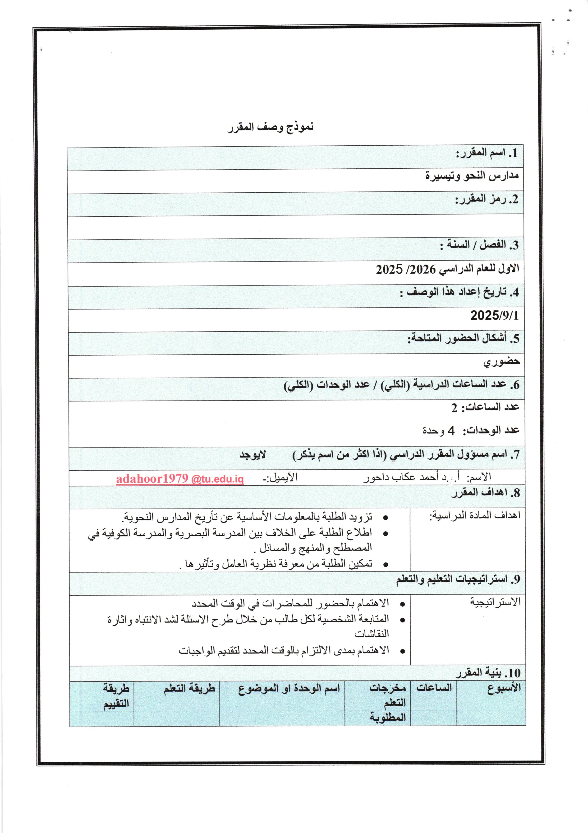

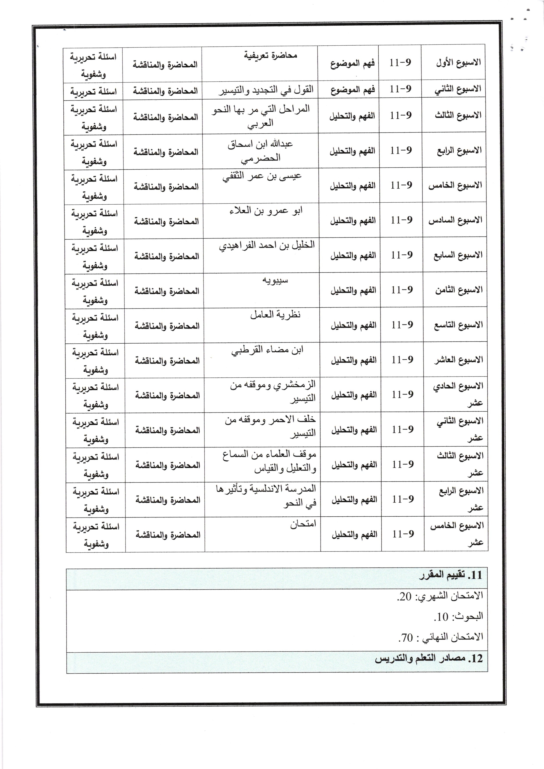

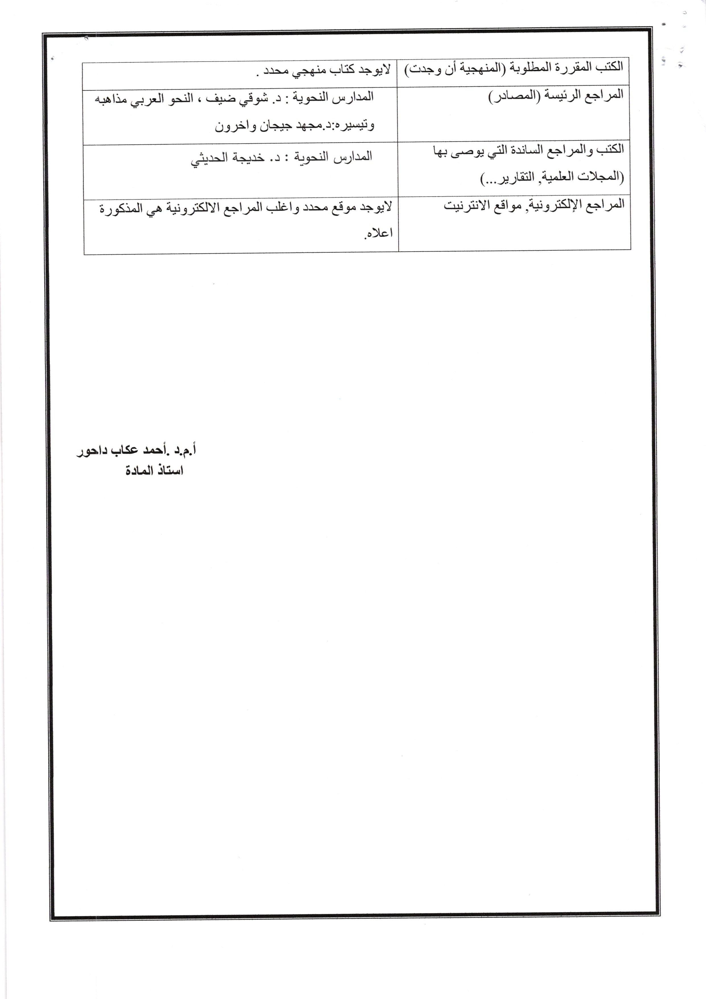

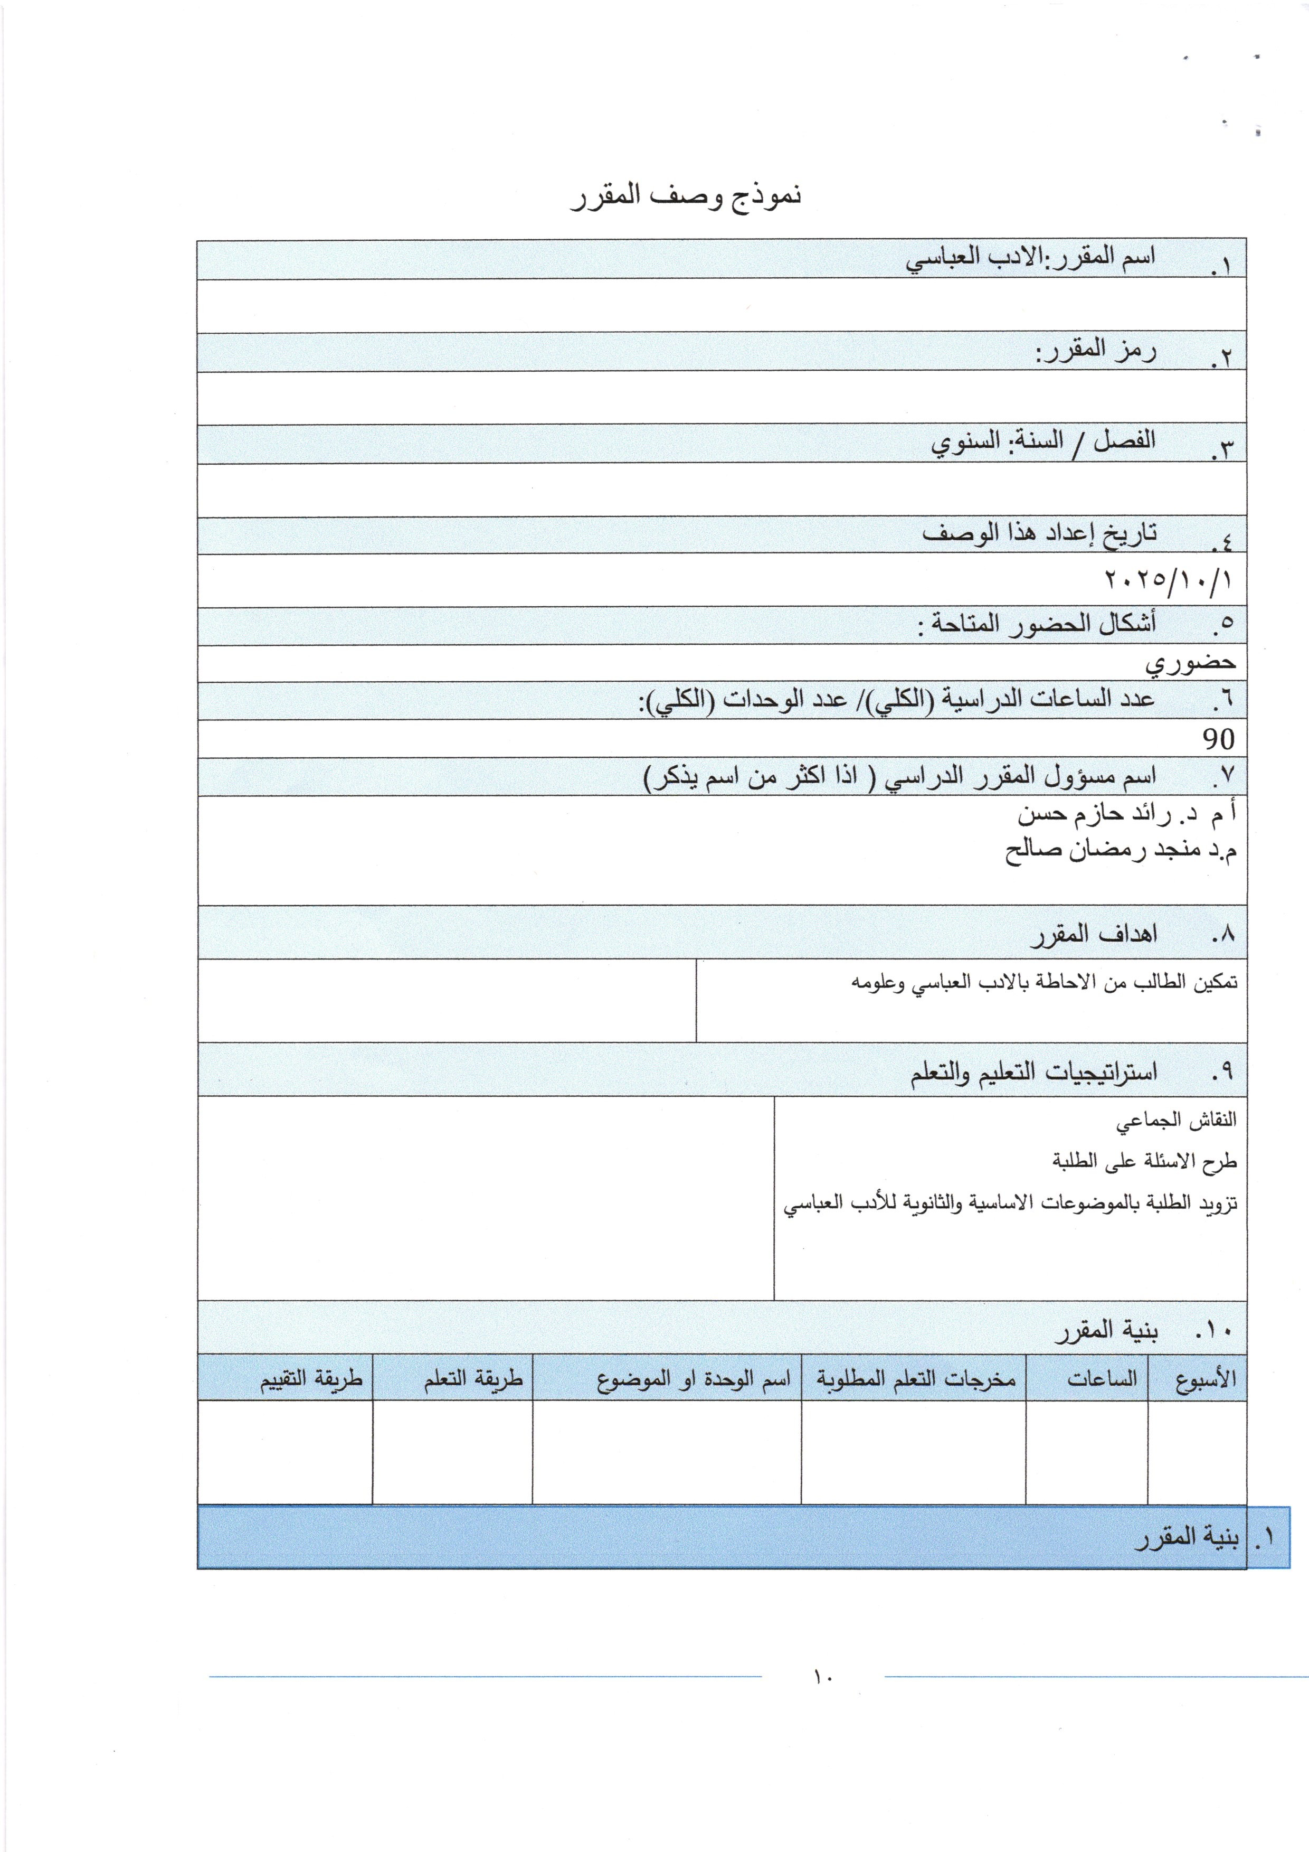

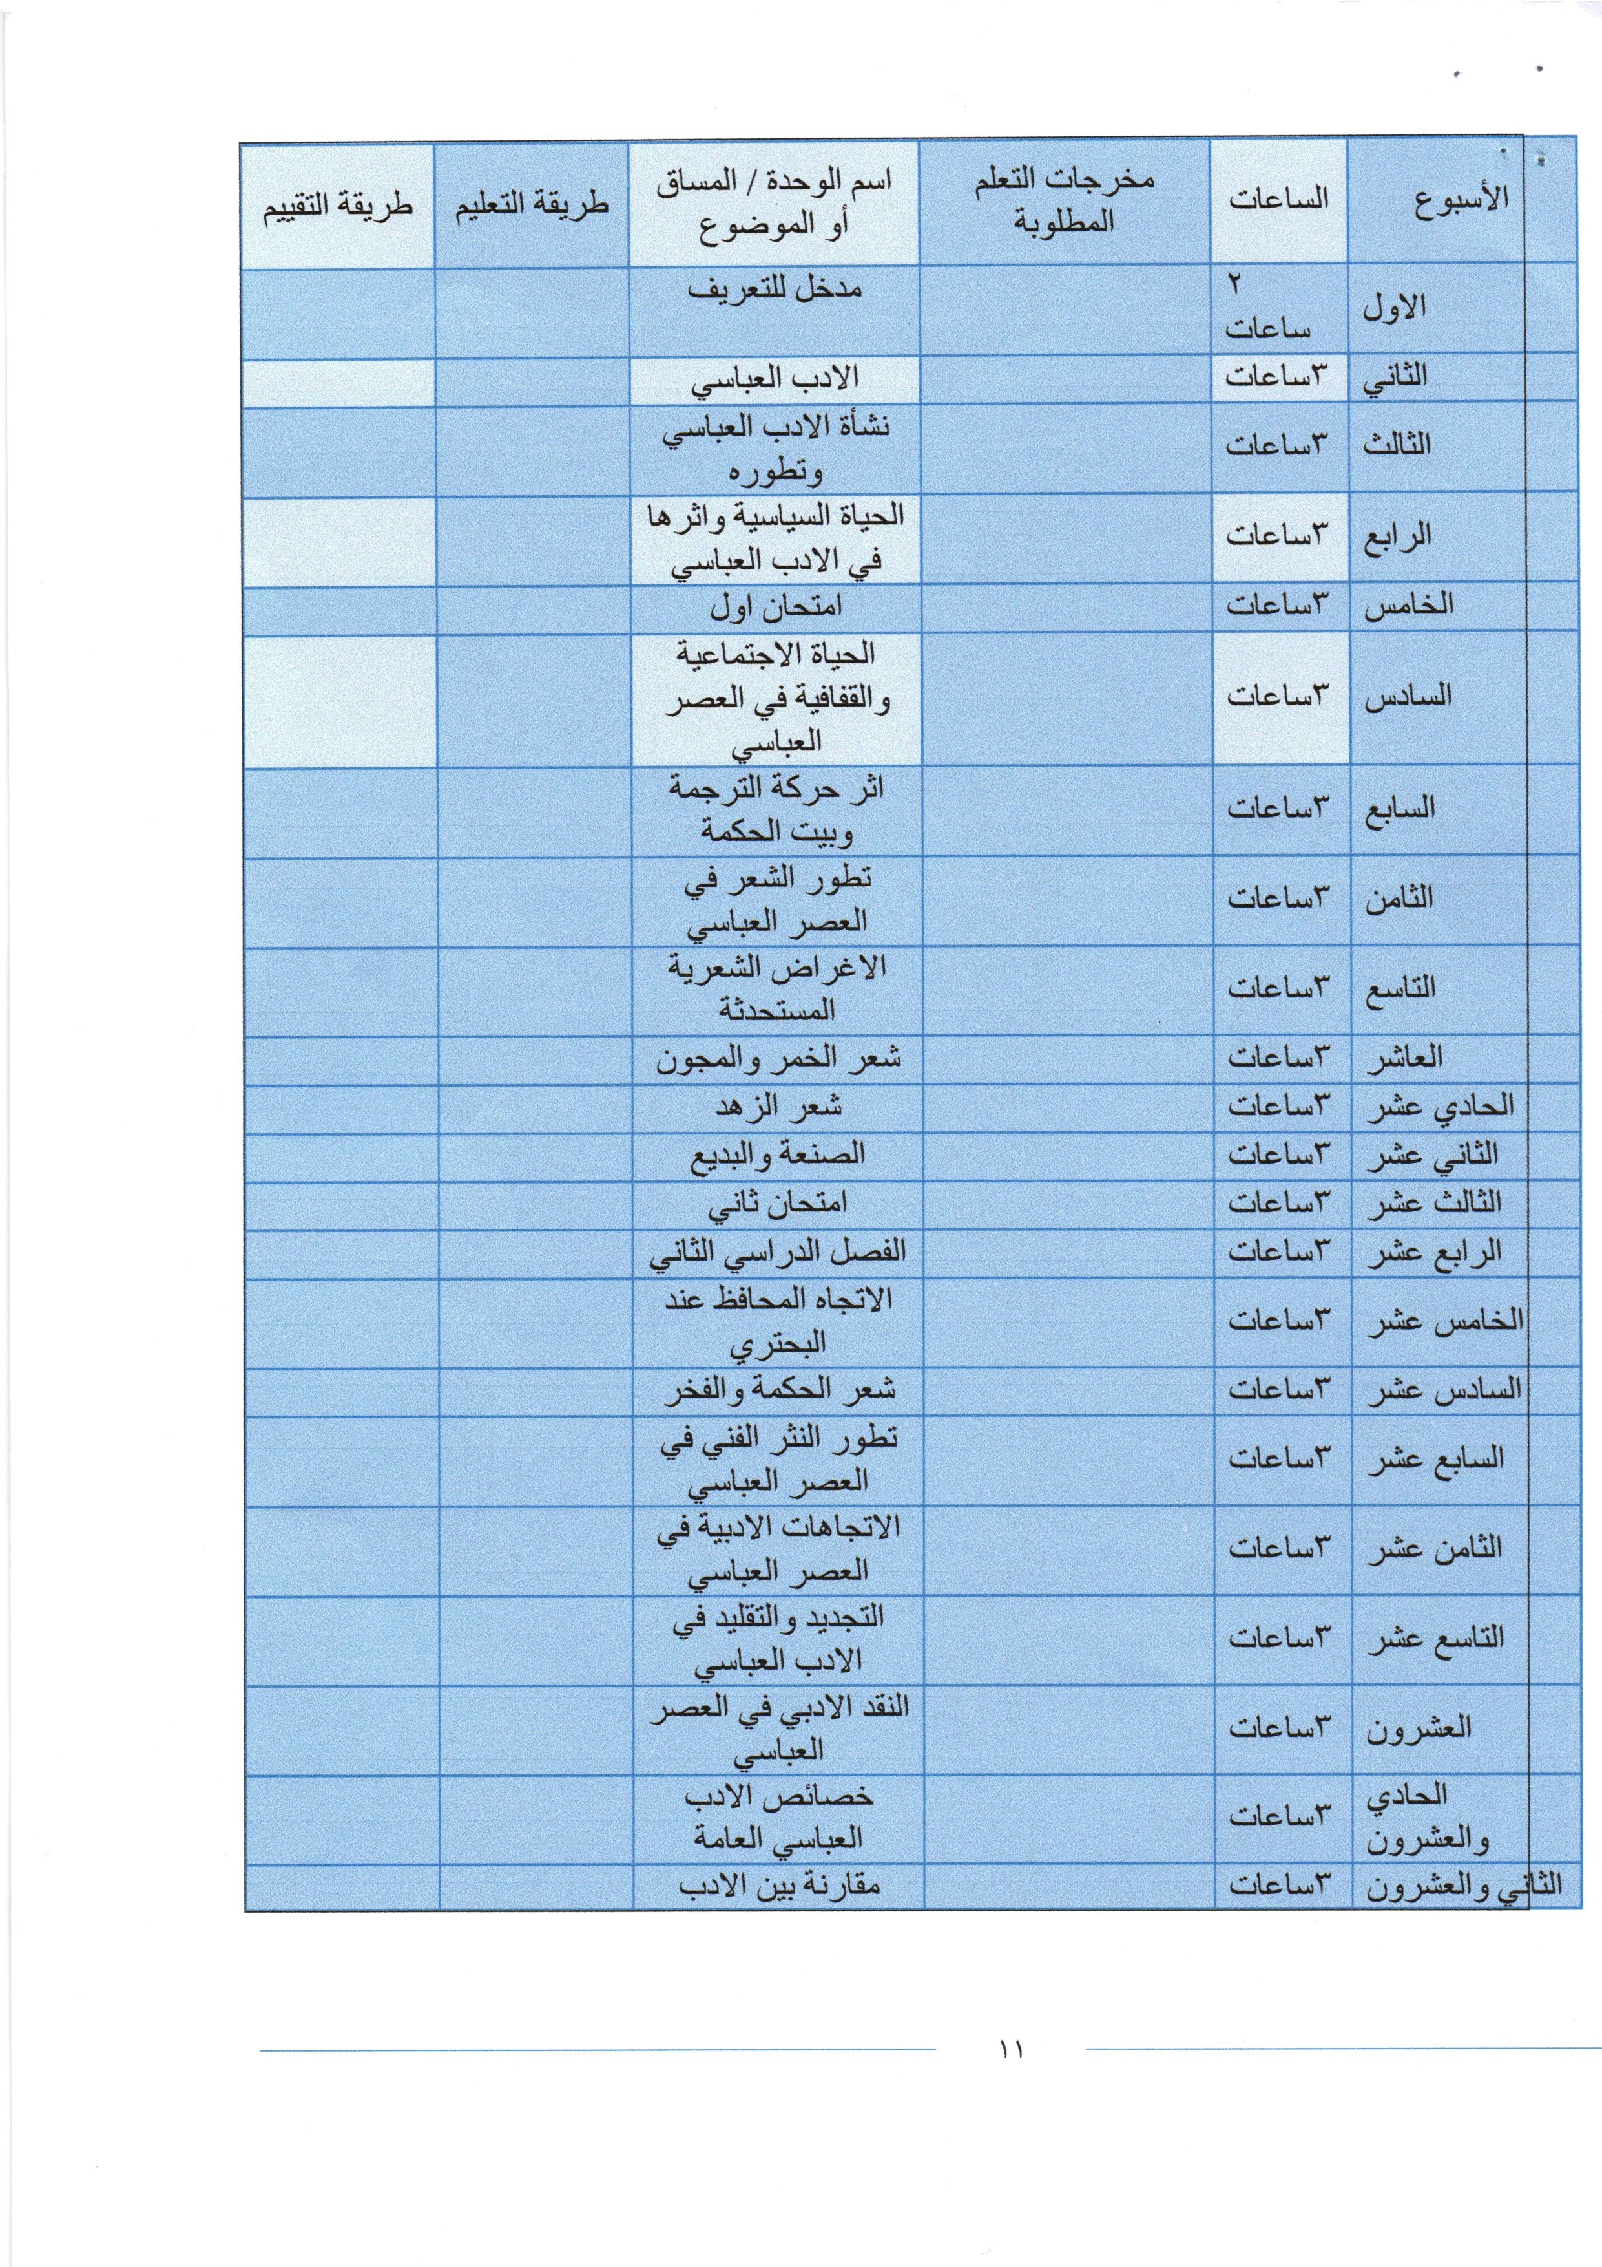

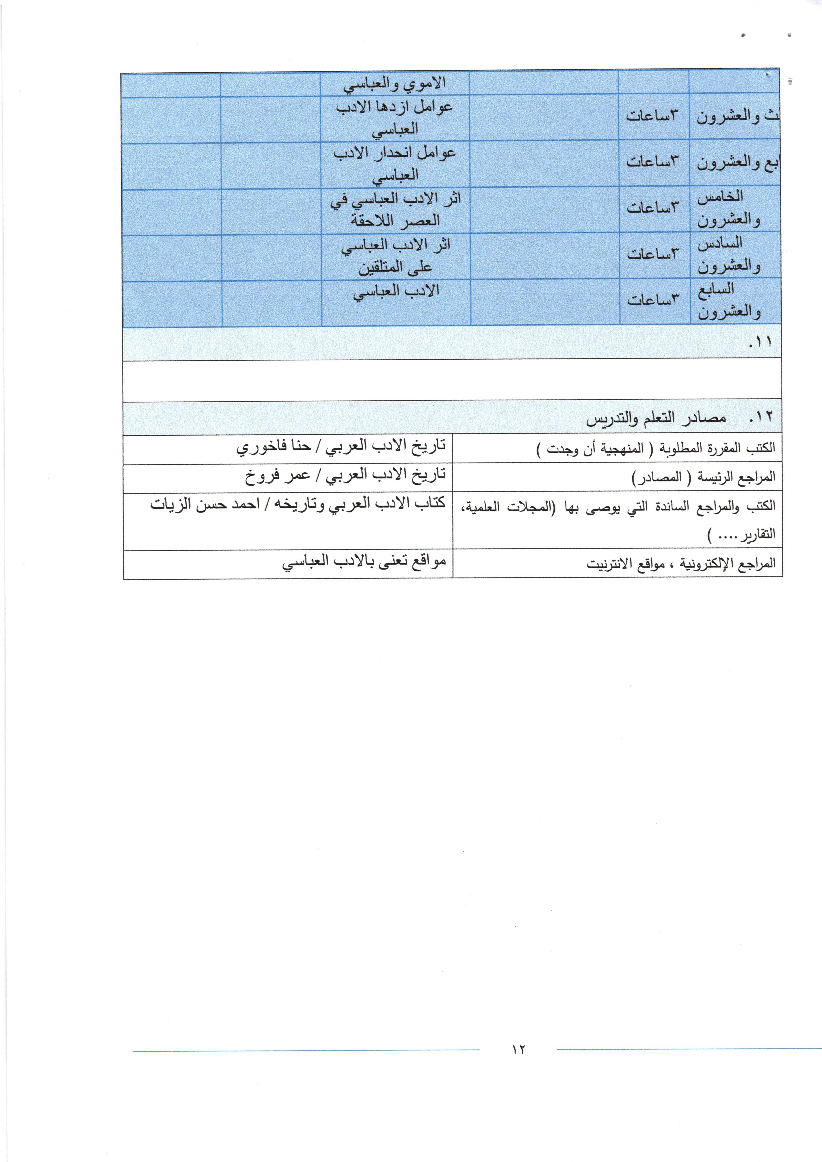

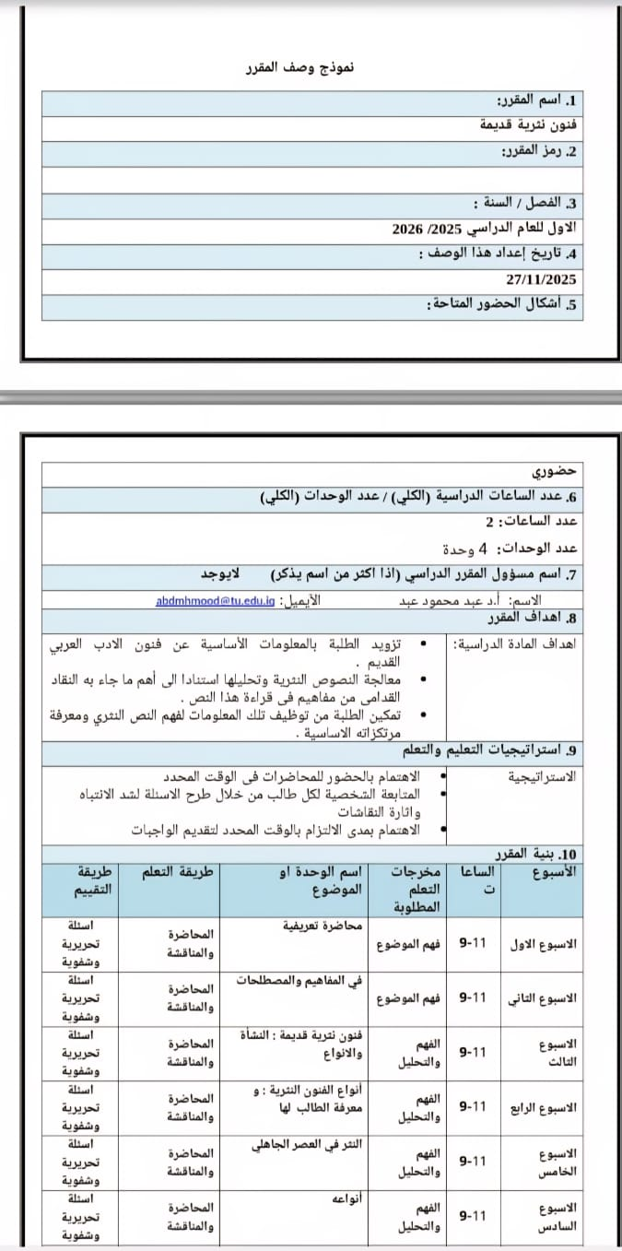

Course description template
1. Course Name:
Ancient prose arts
2. Course code:
3. Term/Year:
First for the academic year 2025/2026
4. Date this description was prepared:
27/11/2025
5. Available forms of attendance:
My presence
6. Total number of study hours / Total number of units
Number of hours: 2
Number of units: 4 units
7. Name of course coordinator (if there is more than one, please list it) - None
Name: Prof. Dr. Abdul Mahmoud Abdul Email: abdmhmood@tu.edu.iq
8. Course Objectives
Course objectives: |  | - supply Students With information Basic About the arts of ancient Arabic literature.  - Processing and analyzing prose texts based on the most important concepts that ancient critics brought forth in reading this text.  - Enabling Students from employment that Information To understand Prose text and knowledge of its basic foundations.
9. Teaching and learning strategies
strategy |  | - Pay attention to attending lectures on time.  - Follow-up Personality per student from during Presentation Questions To tighten Attention And excitement Discussions  - interest Extent Commitment time Specific To present Duties
10. Course Structure
Week | Hours | Required learning outcomes | Unit or topic name | Learning method | Evaluation Method
Week 1 | 9-11​ | to understand the topic | Introductory lecture | Lecture and discussion | Written and oral questions
Week 2 | 9-11​ | to understand the topic | In concepts and terminology | Lecture and discussion | Written and oral questions
Week 3 | 9-11​ | Understanding and Analysis | Ancient Prose Arts : Origins and Types | Lecture and discussion | Written and oral questions
Week 4 | 9-11​ | Understanding and Analysis | Types of prose arts : and the student's knowledge of them | Lecture and discussion | Written and oral questions
Week 5 | 9-11​ | Understanding and Analysis | Prose in the pre-Islamic era | Lecture and discussion | Written and oral questions
Week 6 | 9-11​ | Understanding and Analysis | Types | Lecture and discussion | Written and oral questions
Week 7 | 9-11​ | Understanding and Analysis | First month exam | Lecture and discussion | Written and oral questions
Week 8 | 9-11​ | Understanding and Analysis | Prose in the Islamic Era | Lecture and discussion | Written and oral questions
Week 9 | 9-11​ | Understanding and Analysis | Its types and the evolution it has undergone | Lecture and discussion | Written and oral questions
Week 10 | 9-11​ | Understanding and Analysis | Prose in the Umayyad era | Lecture and discussion | Written and oral questions
Week Eleven | 9-11​ | Understanding and Analysis | Letters and their development at the hands of Abdul Hamid al-Katib | Lecture and discussion | Written and oral questions
Week Twelve | 9-11​ | Understanding and Analysis | Prose in the Abbasid era | Lecture and discussion | Written and oral questions
Week 13 | 9-11​ | Understanding and Analysis | The variety of messages is official and fraternal. | Lecture and discussion | Written and oral questions
Week Fourteen | 9-11​ | Understanding and Analysis | Second month exam | Lecture and discussion | Written and oral questions
Week fifteen | 9-11​ | Understanding and Analysis | Analytical readings of newly developed prose arts (signatures and maqamat) | Lecture and discussion | Written and oral questions

11. Course Evaluation
Monthly exam: 10.
Research: 10.
Daily reports and attendance: 10.
Final exam: 70.
12. Learning and teaching resources
Required textbooks (methodology, if applicable) | There is no specific textbook.
Main references (sources) | - Al-Mu'talif wal-Mukhtalif, by Al-Amidi  - Al-Kamil fi al-Lughah wa al-Adab (The Complete Book on Language and Literature), by Al-Mubarrad  - Songs, by Al-Isfahani .  - Treasury of Literature, by Al-Baghdadi.  - The Animal, by Al-Jahiz .  - Al-Bayan wa al-Tabyeen, by Al-Jahiz .  - Al-Mahbar, by Ibn Habib .  - Gharib al-Hadith by Ibn Qutaybah.
Recommended supporting books and references (scientific journals, reports...) | - A detailed history of the Arabs before Islam .  - History of Arabic Literature: The Pre-Islamic Era, by Shawqi Daif .  - History of Arabic Literature, Farrukh, Ihsan Abbas  - The History of Literature in the Abbasid Era by Nazim Rashid .  - Development and renewal in Arabic literature, Shawqi Daif.  - Scientific journals.
Electronic references, websites | There is no specific location, and most of the electronic references are those mentioned above.

Course description template
1. Course Name:
Issues in Abbasid Literature
2. Course code:
3. Term/Year:
First for the academic year 2025/2026
4. Date this description was prepared:
11/9/2025
5. Available forms of attendance:
My presence
6. Total number of study hours / Total number of units
Number of hours: 2
Number of units: 4 units
7. Name of course coordinator (if there is more than one, please list it) - None
Name: Prof. Dr. Abdul Mahmoud Abdul Email: abdmhmood@tu.edu.iq
8. Course Objectives
Course objectives: |  | - supply Students With information Basic About issues In Abbasid literature.  - Processing poetic and prose texts And its analysis is based on the most important concepts that ancient critics brought forth in reading this text.  - Enabling Students from employment that Information To understand the critical and artistic issues.
9. Teaching and learning strategies
strategy |  | - Pay attention to attending lectures on time.  - Follow-up Personality per student from during Presentation Questions To tighten Attention And excitement Discussions  - interest Extent Commitment time Specific To present Duties
10. Course Structure
Week | Hours | Required learning outcomes | Unit or topic name | Learning method | Evaluation Method
Week 1 | 9-11​ | to understand the topic | Introductory lecture | Lecture and discussion | Written and oral questions
Week 2 | 9-11​ | to understand the topic | In concepts and terminology | Lecture and discussion | Written and oral questions
Week 3 | 9-11​ | Understanding and Analysis | Literary issues: Origins and genres | Lecture and discussion | and oral questions
Week 4 | 9-11​ | Understanding and Analysis | Types of literary issues: and the student's knowledge of them | Lecture and discussion | Written and oral questions
Week 5 | 9-11​ | Understanding and Analysis | Issues in the pre-Islamic era | Lecture and discussion | Written and oral questions
Week 6 | 9-11​ | Understanding and Analysis | Types | Lecture and discussion | Written and oral questions
Week 7 | 9-11​ | Understanding and Analysis | First month exam | Lecture and discussion | Written and oral questions
Week 8 | 9-11​ | Understanding and Analysis | Issues in the Islamic era | Lecture and discussion | Written and oral questions
Week 9 | 9-11​ | Understanding and Analysis | Its types and the evolution it has undergone | Lecture and discussion | Written and oral questions
Week 10 | 9-11​ | Understanding and Analysis | Issues in the Umayyad era | Lecture and discussion | Written and oral questions
Week Eleven | 9-11​ | Understanding and Analysis | Technical issues | Lecture and discussion | Written and oral questions
Week Twelve | 9-11​ | Understanding and Analysis | Issues in the Abbasid era | Lecture and discussion | Written and oral questions
Week 13 | 9-11​ | Understanding and Analysis | Its diversity | Lecture and discussion | Written and oral questions
Week Fourteen | 9-11​ | Understanding and Analysis | Second month exam | Lecture and discussion | Written and oral questions
Week fifteen | 9-11​ | Understanding and Analysis | An analytical reading of newly created poetic texts in poetic and prose genres. | Lecture and discussion | Written and oral questions

11. Course Evaluation
Monthly exam: 10.
Research: 10.
Daily reports and attendance: 10.
Final exam: 70.
12. Learning and teaching resources
Required textbooks (methodology, if applicable) | There is no specific textbook.
Main references (sources) | - Al-Mu'talif wal-Mukhtalif, by Al-Amidi  - Al-Kamil fi al-Lughah wa al-Adab (The Complete Book on Language and Literature), by Al-Mubarrad  - Songs, by Al-Isfahani.  - Treasury of Literature, by Al-Baghdadi.  - The Animal, by Al-Jahiz.  - Al-Bayan wa al-Tabyeen, by Al-Jahiz.  - Al-Mahbar, by Ibn Habib.  - Gharib al-Hadith by Ibn Qutaybah.
Recommended supporting books and references (scientific journals, reports...) | - A detailed history of the Arabs before Islam.  - History of Arabic Literature: The Pre-Islamic Era, by Shawqi Daif.  - History of Arabic Literature, Farrukh, Ihsan Abbas  - The History of Literature in the Abbasid Era by Nazim Rashid.  - Development and renewal in Arabic literature, Shawqi Daif.  - Scientific journals.
Electronic references, websites | There is no specific location, and most of the electronic references are those mentioned above.

Course description template
1. Course Name:

Grammar schools

2. Course code:

3. Term/Year:

Academic year 2025/2026

4. Date this description was prepared:

11/9/2025

5. Available forms of attendance:

My presence

6. Total number of study hours / Total number of units

Number of hours: 2

Number of units: 4 units

7. Name of course coordinator (if there is more than one, please list it) - None
Name: Prof. Dr. Muhannad Majeed Baraa Email: mmb@tu.edu.iq

8. Course Objectives
H Course Objectives: |  | - Increase students' understanding of the subject of school grammar .  - Introducing students to the history of Arabic grammar.  - Enabling Students from employment that Information To understand Grammatical disagreements between grammatical schools and knowledge of the opinions worthy of acceptance and adherence.

9. Teaching and learning strategies
strategy |  | - Pay attention to attending lectures on time.  - Follow-up Personality per student from during Presentation Questions To tighten Attention And excitement Discussions  - interest Extent Commitment time Specific To present Duties

10. Course Structure
Week | Hours | Required learning outcomes | Unit or topic name | Learning method | Evaluation Method
Week 1 | 2 | to understand the topic | Reasons for the emergence of grammar | Lecture and discussion | Written and oral questions
Week 2 | 2 | to understand the topic | Early grammarians | Lecture and discussion | Written and oral questions
Week 3 | 2 | Understanding and Analysis | Basra sets the standard for grammar. | Lecture and discussion | and oral questions
Week 4 | 2 | Understanding and Analysis | Al-Khalil ibn Ahmad al-Farahidi | Lecture and discussion | Written and oral questions
Week 5 | 2 | Understanding and Analysis | Sibawayh | Lecture and discussion | Written and oral questions
Week 6 | 2 | Understanding and Analysis | Al-Akhfash Al-Awsat and his students | Lecture and discussion | Written and oral questions
Week 7 | 2 | Understanding and Analysis | Qutrub, al-Jarmi, and Abu Uthman al-Mazini | Lecture and discussion | Written and oral questions
Week 8 | 2 | Understanding and Analysis | Al-Mubarrad and his associates | Lecture and discussion | Written and oral questions
Week 9 | 2 | Understanding and Analysis | Kufic School | Lecture and discussion | Written and oral questions
Week 10 | 2 | Understanding and Analysis | Al-Kisa'i and his students | Lecture and discussion | Written and oral questions
Week Eleven | 2 | Understanding and Analysis | fur | Lecture and discussion | Written and oral questions
Week Twelve | 2 | Understanding and Analysis | Fox and his friends | Lecture and discussion | Written and oral questions
Week 13 | 2 | Understanding and Analysis | Baghdad School | Lecture and discussion | Written and oral questions
Week Fourteen | 2 | Understanding and Analysis | Second month exam | Lecture and discussion | Written and oral questions
Week fifteen | 2 | Understanding and Analysis | Research discussion | Lecture and discussion | Written and oral questions
Week 16 | 2 | Understanding and Analysis | Andalusian School | Lecture and discussion | Written and oral questions
Week 17 | 2 | Understanding and Analysis | Ibn Malik | Lecture and discussion | Written and oral questions
Week 18 | 2 | Understanding and Analysis | Lecture and discussion | Lecture and discussion | Written and oral questions
Week 19 | 2 | Understanding and Analysis | A comprehensive review of the prescribed textbook | Lecture and discussion | and oral questions
Week 20 | 2 | Understanding and Analysis | Distribution of annual study grades | Lecture and discussion | Written and oral questions

11. Course Evaluation

Monthly exam: 20.

Research: 10.

Daily reports and attendance: 10.

Final exam: 60.

12. Learning and teaching resources
Required textbooks (methodology, if applicable) | - Grammatical Schools by Dr. Shawqi Daif
Main references (sources) | - Grammatical Schools by Dr. Khadija Al-Hadithi
Recommended supporting books and references (scientific journals, reports...) | - Grammatical Schools by Dr. Ibrahim Al-Samarrai
Electronic references, websites | There is no specific location, and most of the electronic references are those mentioned above.

